The Official Publication of ALOA—An International Association of Security Profess

ALOA 06

iOth Anniversary

A/RAP-UP

»LUS!

onuention Photo Hlbum

**oor Closers \***\*\*\*\*\*\*\*\*\*\*\*\*\*\*SCH*3*-D*1*GTT*303*

lhat **is** Behind the Green Label? **BreckH. CampCML**

ND MORE! **PO Box** 47070

Atlanta GA *30362-0070*

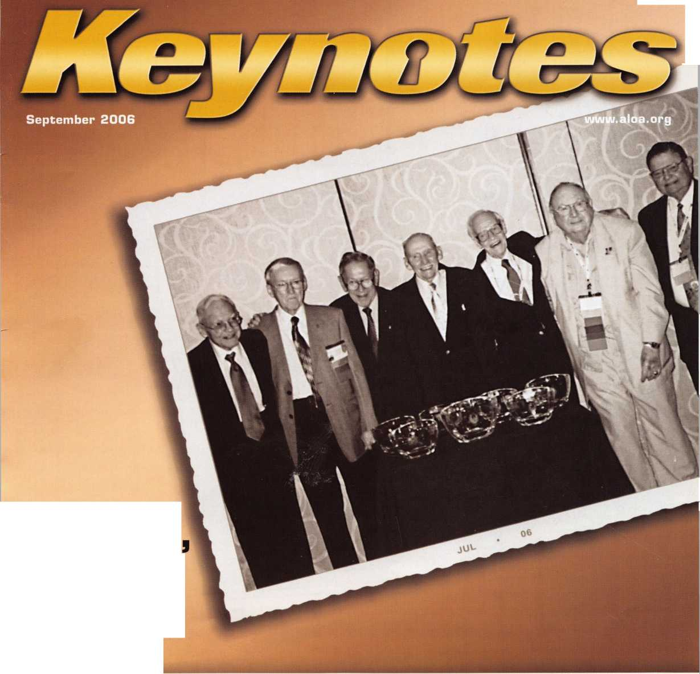

Subject to availability and qualiin afom. Allsta Company, Bridgewater,, INIJ. The " i . dped Hands

**OUR STAND**

**IT’S QUITE POSSIBLY YOUR MOST**

**TRUSTED SIDEKICK**

**Keep it in Good Hands® with Allstate.**

As a small business owner, there are few things you quick certificates of insurance, ID cards, assistance

rely on more than your vehicle to keep you going. with the claims process, and more. All from one of

Your local Allstate agent can help protect it and the most widely recognized names in the business,

your small business with services you need including **Are you in Good Hands®?**

1-800-859-0247

**CALL NOW TO LOCATE YOUR NEARBY ALLSTATE AGENT.**

yillslate

**You’re in good hands.**

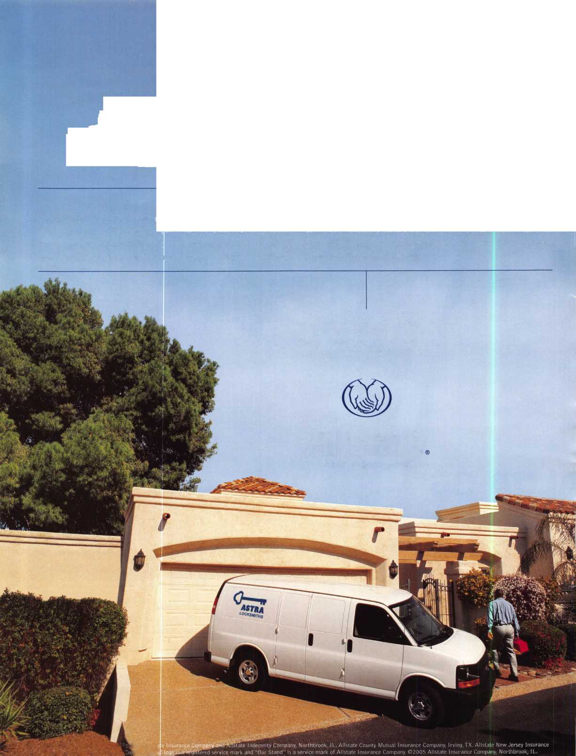

A Name You Know

As a business owner, you know the importance of a  
good name. Your name is your reputation. Your name  
stands for all that you offer in products and services.  
It’s a symbol of who you are. So, we thought you  
might like to know that Allstate, the name you know  
for insuring your personal vehicle and your home,  
also offers a business auto policy to help protect vehi-  
cles used in your locksmith business.

The following are coverages typically included in  
our business auto policy that might be important to  
you as a business owner:

Business Auto Liability coverage

* Higher limits up to $2,000,000 per occur-  
  rence.
* Protects you if you are legally responsible  
  for injuries and damages arising out of  
  the ownership, maintenance, or use of  
  business vehicles.
* Cost is based on several factors, including  
  garage location, type and use of vehicle,  
  and the violation and accident activity of  
  your drivers.
* Additional Insured coverage may be  
  required when you contract with govern-  
  mental agencies or bid on local  
  commercial jobs.
* Generally not available on a personal auto  
  policy.
* Usually is no charge to add an insured to  
  a Commercial Auto policy.

Hired Auto coverage

* Provides liability coverage for those  
  vehicles you rent, hire or borrow for  
  business use.
* The premium for hired auto liability  
  coverage is based on the estimated  
  annual rental cost.
* Tools and Special Equipment
* Provides protection to permanently  
  attached equipment on your vehicle.
* You will need to let your agent know the  
  value of the equipment to include in the  
  cost of the vehicle.

You’re good at your business. Your insurance com-  
pany should be the same way.

Contact an Allstate agent to discuss your business  
auto insurance needs. To be referred to an agent,  
please call 800.859.0247 or email  
[abisO@allstate.com](mailto:abisO@allstate.com).

Subject to availability and qualifications. Insurance coverage  
is subject to policy terms.

Allstate Insurance Company

Allstate Indemnity Company  
Northbrook, IL

Allstate County Mutual Insurance Company  
Irving, TX

Allstate New Jersey Insurance Company  
Bridgewater, NJ

allstate.com

© 2005 Allstate Insurance Company, Northbrook, IL

Get What's  
Coming To You

AIOA continues to provide you with this

Just

1. ALOA Index of Documents (1 pg)
2. Reasons to Join ALOA {2 pg)
3. Locksmith Career Summary (3 pgs)
4. Locksmith School List (1 pg)
5. ACE Class Schedule (1 pg)
6. Certification Information (5 pgs)
7. PRP Category List (1 pg)
8. ALOA Membership Application (1 pg)
9. ALOA List of Benefits (1 pg)
10. ASF Scholarship Application (1 pg)
11. ASF Scholarship Information (1 pg)
12. ALOA Video Library Order Form (1 pg)
13. Safe & Vault Technicians Association Membership

Application/Subscription Form (2 pgs)

1. Recertification Information (4 pgs)
2. Legislation Action Network Newsletter (2 pgs)
3. Various State Law Issues (8 pgs)
4. Industry Position Paper (1 pg)
5. ALOA Convention Class Schedule (3 pgs)
6. ALOA Convention Class Descriptions (30 pgs)
7. ALOA Convention Registration Forms (4 pgs)
8. Board of Directors Nomination Form (2 pgs)
9. ALOA Company Membership Application (2 pgs)

310-515-5027

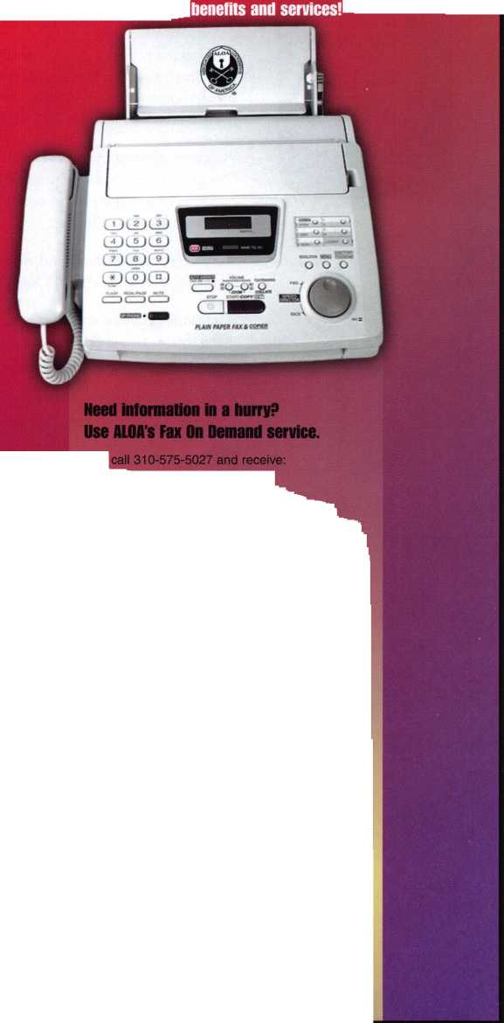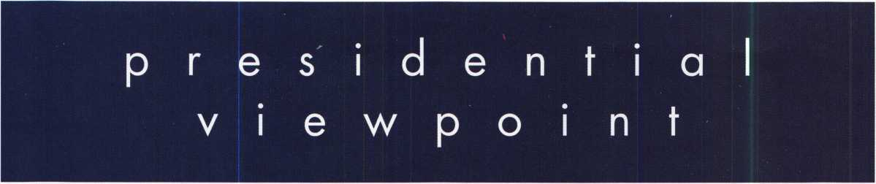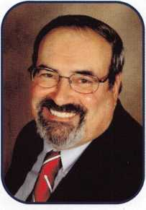

Dear Members,

What a celebration! First, let me thank all those who were present to commemorate ALOA's Fiftieth. Also, thank you to our wonderful staff for doing a golden job with our Fiftieth Anniversary celebration.

We had the honor of having seven charter members present: Connie Maffey, our honorary chairman, Her­man Brust, Jr., Philip Macy, William Mclnerney, Roger Paradise, James L. Taylor and George E. Walters. They shared some wonderful stories and thoughts about ALOA during a special VIP banquet. There, they were presented with a token of ALOAs thanks for having the foresight to create ALOA.

Welcome aboard our new Directors: Dan Floeck, Jr., Keith Whiting, Bobby DeWeese, Tom Foxwell, Sr., Greg Parks, and back for another two years, our Secretary, John Soderland. Leaving behind their wisdom, a special thanks goes out to our departing Board Members: Vernon Kelley, Peter Sarailian, Paul Justen, Gor­don Racine and Jim Jeffries.

The ALOA Scholarship Fund elected a new President, Gordon Racine. They also raised a grand total of $1 3,000 during their Golf Outing. Congratulations!

After writing almost a year about our grand prize, I am pleased to announce the '56 T-Bird will be "living in the land down under". The car was won by Mark Johnson of North Melbourne, Australia. Happy motor­ing, Mark!

One of the happiest duties I have is to present the President's Award, which this year, went to Mary May. As a member of our staff, she has dedicated over twenty-five years to the members of ALOA.

The Ace Award was presented to one of our outstanding instructors, Ed Woods, CML, CPS. Congratulations, Ed!

The week-long celebration was capped off by a black tie preferred banquet with about four hundred peo­ple in attendance. At the celebration, ALOA recognized one of its own with its highest honor, The ALOA Life­time of Outstanding Achievement Award. This long over due honor was presented to Evelyn Wersonick,CML, who has given a lifetime to the promotion of the locksmithing profession.

ALOA was then given recognition of its fifty years of service to our profession with tokens of appreciation from the South Jersey Locksmith Association, the Master Locksmiths of New Jersey, the Institutional Lock­smiths' Association and the Swedish Locksmiths' Association.

We were royally entertained by the "Rat Pack". "Sammy" came back to sing and dance with the attendees until it was time to leave. The celebration was all we could have asked for and more.

But for now, the woods were lovely dark and deep, but we have promises to keep and miles to go before we sleep, and miles to go before we sleep. Those miles are leading on to our next fifty.

Take 'er easy!

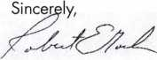

Robert E. Mock

Keynotes • September 2006

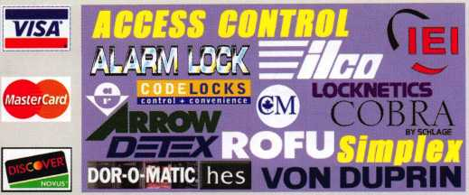

*Peterson*

*unksmtb mm*

*AUTOMOTIVE '''Jet*

***vBtHMB 11*** unauFT^ ***HAT A***

***DETERMINATOR MAJOR (Jg*rspn***

**♦**

**PRQ-LOK**

STRATTEC

***Wedfeco-* -**

Wl £R LOCK

***Why Do Locksmiths Everywhere Buy Supplies at***

***H.L.Eiake?***

**CAL-ROYAL**

jiickson

LCN

**lRCH**

M

N

**SARGENT**

**SCHLAGE**

VON DUPRIN

***He Extremely Competitive  
He E/Z Free Freight Minimums***

***He Same Day Shipping  
He Service with a Smile  
He High Fill Rate  
He Hard to Find Items***

***He E/Z Order Web Site***

***[WWW.HlFUKt.com](http://WWW.HlFUKt.com)***

* ***Order 24 hours a day***
* ***Updated Every Business Day***
* ***Extra Discount for Web Orders***
* ***Personalized Inventory Lists***

**LOCKCRAFT^**

Iockjechimology

*MAJOR*

PFiO-LDH

*LOG ON TO*

[WWW.HLFLAKE](http://WWW.HLFLAKE). com

WSjKj 4Q&C0

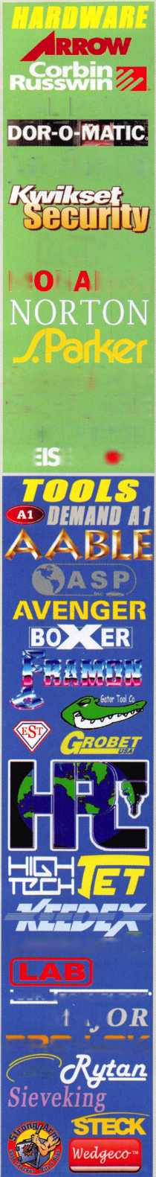

f

e

a

t

u

r

e

s

CRIME PREVENTION 2006

10

50th Anniversary Convention Wrap-Up

Read about this year's exciting highlights from our biggest & brightest convention ever!

**17**

Convention Photo Wrap-Up

After reading the highlights scan through our convention photo album. See if you can spot yourself.

22

Kaba Picks a Winner

Kaba recently picked a winner in the "You could win a Trip to Vegas & Ultimate Lockshop Package" sweep- stakes. Find out who won.

**26**

Behind the Green Label

Greg Perry shows you what to expect to find behind the green label.

by Greg Perry

**30**

Service Standards

Read on to find out the key to becoming like the business that you love.

**AD INDEX**

**Allstate Inside Front Cover**

**Fax on Demand 1**

**HL Flake 3**

**ALOA 2007 7**

**Pacific Lock 13**

**IR 19**

**Clearstar 21**

**PBP 21**

**Top Notch 23**

**Safetech 2007 25**

**Ben Jim 27**

**Vingcard/E-safe 29**

**ELF Convention 2007 29**

**Pacific Lock Conference 2007 31**

**Serlac 33**

**Jameson Code 35**

**Adesco 37**

**A&B 42**

**Turn 10 42**

**Maxcess 42**

**Ultralift 43**

**Door Jamb 43**

**Lockmasters Inside Back Cover**

**CCL Back Cover**

**Departments**

|  |  |  |  |  |  |  |  |  |
| --- | --- | --- | --- | --- | --- | --- | --- | --- |
|  |  |  |  |  |  |  |  |  |
| Presidential |  | Executive | 5 | Calendar | 8 | Classified | 36 | Legislative 40 |
| Viewpoint | 2 | Applicants .... | 6 | Core | 9 | Associate |  |  |
|  |  |  |  |  |  | Members | 38 |  |

Visit our NEW website at [www.aloa.org](http://www.aloa.org)

executive

Volume 52, Issue 8

Additional contact information for the ALOA Board and most Keynotes authors is  
available through "Locksmith Search" on the ALOA Web site- [www.aloa.org](http://www.aloa.org) or by  
contacting the ALOA office at 3500 Easy Street; Dallas, TX 75247; (800)532-2562;

FAX (214)819-9736; e-mail [aloa@aloa.org](mailto:aloa@aloa.org).

Editor

Betty Southerland [betty@aloa.org](mailto:betty@aloa.org)

Advertising Sales

Kim Hammond voice: 817-645-6778

Fax: 817-645-7599  
e-mail: [adsales@aloa.org](mailto:adsales@aloa.org)

Executive Director

Charles W. Gibson, Jr., CAE [charlie@aloa.org](mailto:charlie@aloa.org)

Associate Executive Director

David Lowell, CML, CMST [david@aloa.org](mailto:david@aloa.org)

Convention & Meetings Manager

Jo Anne Mims [joanne@aloa.org](mailto:joanne@aloa.org)

Operations/Membership Manager

Mary May [mary@aloa.org](mailto:mary@aloa.org)

Director of Creative Services

Betty Southerland [betty@aloa.org](mailto:betty@aloa.org)

Director of IT Operations

Greg K. Jackson [greg@aloa.org](mailto:greg@aloa.org)

Contributors

Jerome Andrews, CML Ray D'Adamo, CML

Paul Chandler, CRL Billy Edwards, CML

Claire Cohen, CML Dan Graffeo, CRL,CMST

Brian Costley, CML, CMST Jim Hancock, CPL

Eric Costley, CRL Jeff Nunberg, CML, CMST

Mission Statement: The Associated Locksmiths of America, Inc. is dedicated to enhancing the professionalism, education and ethics among  
locksmiths and those in related sectors of the physical security industry. With approximately 10,000 members in the United States, Canada and the  
freeworld, ALOA is poised to help members obtain the knowledge, the strength, and the confidence to perform their role in the physical security field  
with pride and dignity. But it is only through active involvement and participation that ALOA can fully achieve its potential—and can help members to  
achieve theirs.

Policies: **Keynotes**® is the official publication of the Associated Locksmiths of America, Inc. (ALOA). **Keynotes®** acts as a moderator without approving,  
disapproving, or guaranteeing the validity or accuracy of any data, claim, or opinion appearing under a byline or obtained or quoted from an acknowl-  
edged source. The opinions expressed by the authors do not necessarily reflect the official views of ALOA. Also, appearance of advertisements and  
new products or service information does not constitute an endorsement of products or services featured by the Association. The Association does not  
accept responsibility for the inaccuracy of any data, claim, or opinion appearing in this publication, due to typographical errors on the part of the  
authors, Association staff or its agents.

Editor's Note: This publication is designed to provide accurate and authoritative information in regard to the subject matter covered. It is provided  
and disseminated with the understanding that the publisher is not engaged in rendering legal or other professional services. If legal advice and other  
expert assistance is required, the services of a competent professional should be sought.

Authors' Payment: Payment for eligible submissions to Keynotes will be based on the following criteria: topic, time spent and past contributions. Authors who  
regularly submit to **Keynotes**® are generally paid a higher rate. The latter is especially true of authors who write to fit specific editorial needs and submit said copy  
by **Keynotes**® deadlines. As a general guideline: Average payment for a 750 word, business or 'light' technical article would be $200. Payment for a 1500 word  
article involving significantly higher time and research efforts would be $400.

Payment will not be offered for articles submitted by ALOA employees or members of the ALOA Board of Directors (unless material is of a technical  
nature), nor for articles submitted by a company that promote that company's products or services. ALOA reserves the right not to pay for articles sub-  
mitted by an individual(s) that promote a particular company's products or services.

Disclaimer: The Associated Locksmiths of America, Inc., (ALOA), reserves the right to refuse any article for any reason. Additionally, ALOA reserves  
the right to edit, amend or modify any article submitted for publication in order to preserve technical accuracy, clarity, fairness or grammatical cor-  
rectness. ALOA will make the best efforts to notify the author of any changes. The extent of ALOA's liability for any article or information contained  
therein will be a notice of correction or retraction in the next possible issue.

**Keynotes**® (ISSN 0277 0792) is published monthly except for the combined June/July issue by The Associated Locksmiths of America, Inc.,  
3500 Easy St., Dallas, TX 75247-6416. Telephone: (214) 819-9733; FAX (214) 819-9736; e-mail [aloa@aloa.org](mailto:aloa@aloa.org). Subscription rates for  
members—$ 15.00 per year. Periodical class postage paid at Dallas, Texas. POSTMASTER: Send address changes to: Keynotes, 3500 Easy St., Dallas,  
TX 75247-6416. © Copyright 2003, All rights reserved. No part of the contents may be reproduced or reprinted in any form without prior  
written permission of the publisher.

Comptroller Kathy J. Romo

Membership Coordinator Shelly Jett

Convention & Meetings Assistant Karen Lyons PRP/Education Coordinator Mayra Ocon

Mail Room Coordinator Kevin Wesley

Creative Media Specialist Margarita Garza

Accounting Coordinator Joyce Nixon

Executive Assistant Sue Langford

Assistant Education Manager Bob Stafford

Legislation Manager Tim McMullen

Receptionist Shelley Melton

Randy Simpson, CML, CPP Tom Seroogy Robert Stafford, CML Charles Stephenson, CPS

Dave Thielen, CML Dennis Watanabe, CML, CMST

Greg Perry, CML,CPS

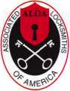

President

Robert Mock  
(856) 863-0710  
[president@aloa.org](mailto:president@aloa.org)

Secretary

John Soderland, CML, CMST  
(414) 327-5625  
[secretary@aloa.org](mailto:secretary@aloa.org)

Directors, Northeast

Tom Foxwell  
(410) 206-5772  
ned i rector@a loa. org

Robert D. DeWeese, CML  
(410)285-0101  
[nedirecfor@aloa.org](mailto:nedirecfor@aloa.org)

Directors, Southeast

Tom Gillingham, Jr., CML, CPS  
(615) 264-0747  
[sedirecfor@aloa.org](mailto:sedirecfor@aloa.org)

Ken Kupferman, CML  
(813) 232-7600  
sed irector@a loa. org

Director, North Central

William Smith, RL  
(920) 893-5282

Guy Spinello, RL  
(815)394-1000  
ncd i recfor@aloa. org

Director, South Central

CD Lipscomb, CML, CPS  
(903) 874-3522  
[scdirector@aloa.org](mailto:scdirector@aloa.org)

Directors, Southwest

Greg Parks  
(858) 271-1155  
swdirector@aloa. org

Julie McCluney, CRL  
(714) 636-5652  
swdi rector@aloa. org

Director, Northwest

Keith E. Whiting, CML, CFL  
(360) 601-5656  
nwdirector@aloa. org

Director, European

Hans Mejlshede, CML  
(453) 539-3939  
[eurdirector@aloa.org](mailto:eurdirector@aloa.org)

Director, Associate

Dan Floeck  
(800) 231-4105  
asdirector@aloa. org

Trustees

[trustees@aloa.org](mailto:trustees@aloa.org)

Randy Simpson, CML  
(281) 240-5959

JohnJ. Greenan, CML, CPS  
(773) 486.2030

William Young, CML, CPS  
(610) 647-5042

Past Presidents

2003-2005 William Young, CML, CPS  
2001-2003 Randy Simpson, CML  
1999-2001 John Greenan, CML, CPS  
1997-1999 Dallas C. Brooks  
1995-1997 David Lowell, CML, CMST  
1993-1995 Breck Camp, CML  
1991-1993 Henry Printz, CML  
1989-1991 Evelyn Wersonick, CML, CPS  
1987-1989 Leonard Passarello, CPL  
1985-1987 Joe Jackman, CML  
1983-1985 Stanley Haney, CPL  
1981-1983 Louis LaGreco, CPL  
1979-1981 John Kerr, RL  
1977-1979 Clifford Cox, CML  
1974-1977 Charles Hetherington  
1972-1974 Gene Laughridge  
1970-1972 William Dutcher, RL  
1968-1970 Constant Maffey, RL  
1966-1968 Harold Edelstein, RL  
1964-1966 William Meacham  
1962-1964 Robert Rackliffe, CPL  
1960-1962 Edwin Toepfer, RL  
1956-1960 Ernest Johannesen



Keynotes • September 2006

Mobile

Bellefonte

Bedfordshire

Pete Thornton

Thorsby

Anthony J. Doody II

Sponsor: Donny W. Rudd CPL

|AZ

Phoenix

Warren F. Grams Jr, CRL

Sponsor: Bruce E. Tinsley CRL

CA

Hollister

Edward J. Ortiz

Lodi

Jason A. Glissman

Sponsor: Glenn A. Glissman CML Oceanside

William J. Rae

San Jose

Flip R. Morton

CO

Castle Rock

Harlan Worden

Sponsor: Skip Bladen CRL

CT

Waterford

Kevin B. Cedio

Sponsor: John K. Humphreys CRL

Miami

Michael G. Nettles

Sponsor: Jay J. Wiener Orlando

Daniel Gonzalez

GA

Cedartown

Pamela Vice

KS

Ottawa

Robert Coyan

Sponsor: R. Kent Lash CRL

MD

Dickerson

Oscar Lopez

Silver Spring

**Rene C. Lopez**

MO

Maryville

Mitch A. Nelsen

NY

Congers

William Rydzewski

OH

Trenton

Scott W. Franer

Sponsor: Terry W. McClain CRL

James E. Fields

Darrell Furfaro

Downingtown

Douglas Scott

Kenhorst

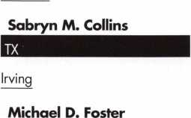

Temple

Jim Fetherman

Sponsor: Robert J. Reynolds CRLy CPS

VA

Fredericksburg

James L. Bickers

Sponsor Donald H. Shiles RL Roanoke

James D. Washburn III

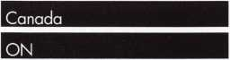

Cambridge

Martin R. Brown

Sponsor. David Federico Elmvale

Domenic Mucci

Sponsor Peter Sarailian CRL

Scott Dymock

Sponsor Ken Dale

Japan

Fujiyoshida Yamanas

Taro Maeda

Sponsor: Takashi Kuwana CRL Fukuokashi Fukuoka

Yuji Tanaka

Sponsor: Takashi Kuwana CRL Ishikarigun Hokkaid

Koichi Sato

Sponsor: Takashi Kuwana CRL

Mexico

Mexico City

Luis De La Rosa

Sponsor: Julio Rafael De La Rosa

These applicants are scheduled for clearance as members of ALOA. The names are published for member review and comment within 30 days of this Keynotes issue date, respectively, to ensure  
applicants meet standards of ALOA's Code of Ethics. Protests, if any, should be addressed to the Membership Department and must be signed. Active Membership applicants (a) have worked in  
the industry two or more years. Allied Membership (AL) applicants are not locksmiths, but work in a security-related field. Apprentice Membership (AP) applicants have worked in the industry less than two years.

Keynotes • September 2006



Start Your Engines!

This year, with a great location and a schedule chock-full of exciting classes and events, we are pulling out all the stops to celebrate the ALOA Convention and Security Expo in Charlotte, North Carolina.

Having built an international reputation among locksmiths as a powerful resource to explore industry innovation and form industry alliances, ALOA 2007 is the ideal place to learn, network or to showcase your security-related business on the show floor.

This year we've thought of everything from an exciting location to a comfort­able hotel and a convention center that is equipped to handle your every need. The exhibit hall promises to be overflowing with the latest technology and new mer­chandise.

july 22-29, 2007

charlotte, north Carolina

\ t

4 5

^x'lOOOr/m'n 0

**7**

Al_OA zooy 8

0

aloa convention and security expo

*51****st ANNUAL***

Don't miss out!

Order Your Registration Packet TODAY!

upcoming events

|  |  |  |
| --- | --- | --- |
| »- | 9/15-16 Doyle Security Products  20th Annual Trade Show 8 | Jovan Security Distributors  Educational Weekend 10th Annual Locksmiths Security Show and Education Conference |
| CL  UJ | Minneapolis, MN | September 29-30 and October 1 st, 2006 |
| (/) | Contact: Chantelle GailagF | er 2350 Midland Avenue, Toronto, ON MIS 1P8 |
|  | 800-333-6953 | Contact: Larry Malo 416-288-6306orvisit[www.jovanlock.com](http://www.jovanlock.com) |

10/11-15 SERLAC Convention & Sec rity Expo Orlando, FL

Contact: James Barnhardt,

P 813-689-5979

11/18 OMLA Class - Access Control, CCTV, Nurse Call, Etc  
Contact: John Ruperd (417J-926-3689



**UPCOMING ACE CLASSES UPCOMING PRP SITTINGS**

|  |  |  |  |
| --- | --- | --- | --- |
| 9/15/2006 | Minneapolis, Minnesota • ACE Classes  Doyle Security Products Trade Show  Contact: Chantelle Gallagher | 9/7/2006 | Thursday 9:00 am • Dallas, TX • ALOA  ALOA Certification 800-532-2562 x203 |
| 10/5/2006 | 800-333-6953  Anaheim, California • ACE Classes | 10/12/2006 | Thursday 9:00 am • Dallas, TX • ALOA  ALOA Certification 800-532-2562 x203 |
|  | Clark Security Products  Contact: Joan Emrick  619-718-7308 | 10/13/2006  10/28/2006 | Friday 6:00 pm • Portland, OR • Pacific Locksmiths Association Bill Botek, CRL 503-644-9881  Saturday 8:00 am • Roseville, Ml • LSA |
| 10/10-13/2006 | Portland, Oregon • ACE Classes  Pacific Locksmiths Association |  | Robert Noble, CML 810-385-9329 |
|  | Contact: Bill Botek, CRL  503-644-9881 | 10/29/2006 | Sunday 10:00 am • Cherry Hill, NJ • GPLA  Robert Schuetrumpf, CRL 856-486-9280 |
| 10/23-28/2006 | Appleton, Wisconsin • ACE Classes  Fox Valley Technical College  Contact: Ann Kading | 11/19/2006 | Thursday 9:00 am • Dallas, TX • ALOA  ALOA Certification 800-532-2562 x203 |
| 12/4/2006 | 800-735-3882x2482  Dallas, Texas • ACE Classes | 11/20/2006 | Saturday 8:00 am • Cary, NC • North Carolina Locksmith Assc. Granger L. Marley 919-859-6060 |
|  | ALOA Training Center  Contact: [education@aloa.org](mailto:education@aloa.org)  800-532-2562x104 | 12/9/2006 | Saturday 3:00 pm • Dallas, TX • ALOA  ALOA Certification 800-532-2562 x203 |
|  |  | Contact the ALOA Education | |

Department for a list of classes and training offered in-house.

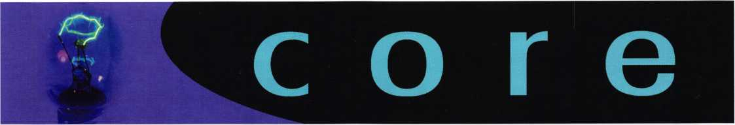

In Memory

We are saddened by the death of Michael Tingler, CML. Mike had been a locksmith in Maryland for many years. He was a long-time member of ALOA.

Locksmith Awarded 2006 DICKIES NORTH CAROLINA WORKER OF THE YEAR®

15th Annual Awards Honor Nation's Workforce

The 2006 North Carolina Worker of the Year is Shane Ellison, a locksmith/safe technician from Lenoir. He was nominated by his wife, Ann, who said in her winning entry, "From fighting fires as a dozer operator with the North Carolina Forest Service to taking on the challenges of starting his own business, he really excels. He works hard, sometimes too hard, long days and many early mornings - he's always there to help people who are in a jam. To him, hard work is just a part of life."

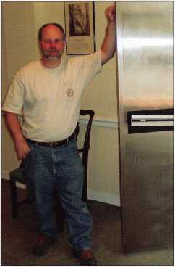

Mr. Ellison, father of two, has had his shop  
Shane Ellison's A Locksmith for more than 20  
years. He says he is one of the few bank vault  
specialists in the United States, and that he  
loves his job.

"I am one of the luckiest guys in the country,

because whereas most guys have a hobby like golf, my job is my hobby," he said.  
"I've been cracking safes since I was a little kid, so to be able to do something you  
love and to be able to provide for your family is a wonderful thing."

Wisconsin Celebrates Professional Locksmiths Week

Jim Doyle, Governor of Wisconsin recently  
declared October 1-7 2006 as Professional  
Locksmiths Week to coincide with the observance of  
October's National Crime Prevention Month. The  
proclamation reads: "Whereas, professional lock-  
smiths dedicate endless hours of time and almost  
unlimited finds to advance their education in certi-  
fied Associated Locksmiths of America (ALOA)  
courses; and Whereas, professional locksmiths  
respond to calls 24 hours a day, 7 days a week,  
365 days a year; and Whereas the work of a pro-  
fessional locksmiths plays a major role in the pre-  
vention of crime as well as helping to secure homes  
and automobiles and the individuals who live in or  
use them; and Whereas, professional locksmiths  
must pass numerous criminal investigation tests and

are also expected to be knowledgeable of all laws and the rights of property owners;  
and Whereas, professional locksmiths are genuinely concerned with crime prevention  
and work hand in hand with law enforcement,

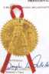

-44-

Now, therefore, I, Jim Doyle, Governor of the State of Wisconsin, do hereby proclaim October 3-9, 2005 which coincides with the October observance of National Crime Prevention month, as Professional Locksmiths Week in the State of Wisconsin, and commend this observance to all citizens.

Security Plus Locksmith wins Kaba Access  
Control's ALOA Product Giveaway

Kaba Access Control congratulates  
John Hughes with Security Plus  
Locksmiths in Anaheim, CA as the  
Grand Prize Winner of Kaba  
Access Control's $2,000 ALOA  
product giveaway. As the winner of  
this drawing, John receives a cross  
section of Kaba's comprehensive  
access control line, including the  
Simplex LI 000 and 5000 Series  
and the E-Plex 2000 and 5000

Series. The contest was open to all locksmiths who stopped by the Kaba booth and  
registered by filing out a card.

The Simplex and E-Plex product lines offer a solution for every door and at every budget. Built on five decades of reliable and convenient keyless entry, this line pro­vides everything from the simplicity of mechanical single code access to the added security and features of electronic access control.

Oklahoma Locksmiths to be Licensed Statewide for the First Time

With the recent overwhelming passage of Senate Bill 1741 and Governor Brad Henry's signature, the State of Oklahoma now requires all locksmiths in Oklahoma to obtain a state license. The new law goes into effect on January 1, 2007. After January 1, 2007, Oklahoma locksmiths will have three months to obtain an Oklahoma Locksmith License. Currently, there are nine other states that have a lock­smith license requirement, with three other states passing laws to enact the require­ment. Those states are Oklahoma, Alabama, and Tennessee.

The Oklahoma Master Locksmith Association received awards by the Associated Locksmiths of America (which is the national association for locksmiths) for their work on state legislation with the licensing of Oklahoma Locksmiths. According to Lowell Roberts (an Oklahoma City Locksmith), the new law will protect the public from unscrupulous locksmiths who come in to a community.

The Oklahoma Master Locksmith Association in conjunction with the Oklahoma State Department of Health, Occupational Licensing Division will make a presentation on the Proposed Alarm and Locksmith Industry Regulations to all locksmiths in attendance. The meeting will be held August 19, 2007, at 3:30 p.m. at the Crowne Plaza Hotel located at 2945 Northwest Expressway, in Oklahoma City, Oklahoma 73112. The general business meeting for OMLA will follow at 5:30 P.M. in the same location.

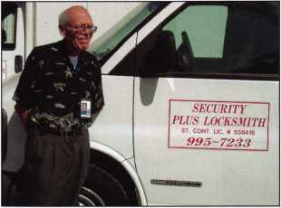

Keynotes • September 2006

Mission

Accomplished

**LAS VEGAS**

19! • 2006

Thank You to ALOA

Golf Tournament Sponsors

ASSA High Security Locks Golf Tournament

ASSA Abloy Retrofit Security Solutions

ARROW Lock & Door Hardware

Medeco High Security Locks

ASSA Abloy Retrofit  
Security Solutions  
Golf Shirts

AMSEC  
Golf Hats

Strattec Golf Balls

Lucky Line Golf Bag Tags

|  |  |
| --- | --- |
| 2006 Si | >onsors! |
| Pacific Lock | Corporate Safe |
| Banner in Kick OIF Party | Display outside show |
| H.L. Flake | ClearStar |
| Kick Off Party | Popcorn Bags |
| Assa Abloy Americas | Medeco |
| Banner at Entrance | International Reception |
| La Card | Kaba Ilco |
| Banner at Entrance, Insertion in Bags | Registration Bags  Ingersoll Rand Security |
| Kaba Ilco | Technologies |
| Insertion in Bags  Videx  Banner @ Entrance | Lanyards |



Keynotes • September 2006

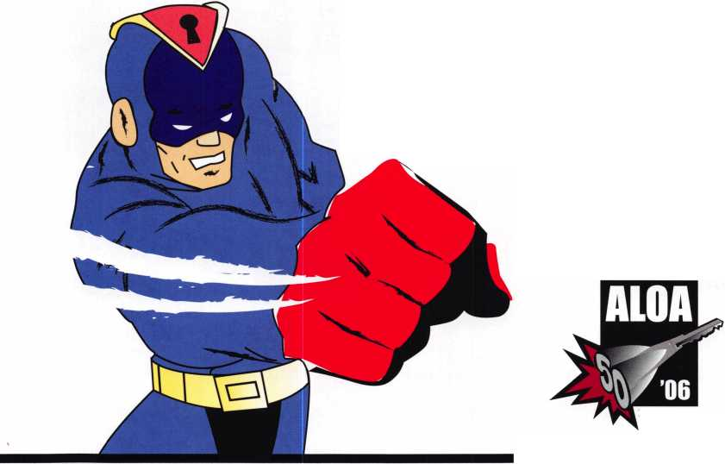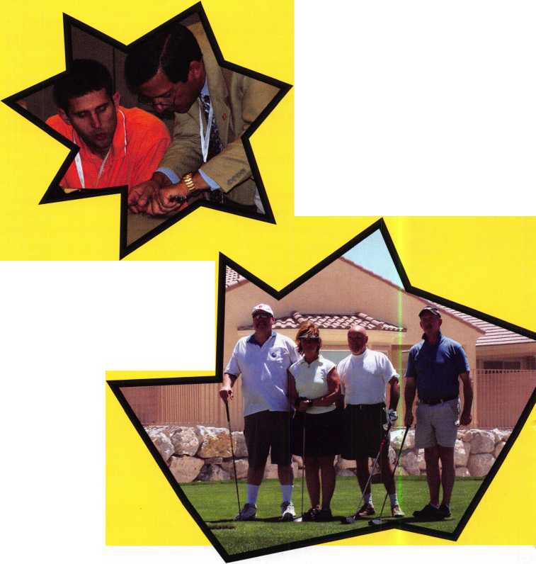

Award Winners

ALOA Award

Evelyn V. Wersonick, CML

President’s Award  
Mary May

ACE Award

Edward Woods, CML, CPS

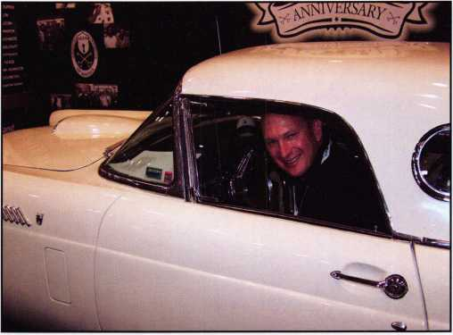

THANK YOU T-Bird Sponsors:  
Compx, FireKing Security Group,  
Ingersoll-Rand Security Technologies

4,368 Security Professionals from around the world traveled to Las Vegas in July for the 30th Anniversary of the ALOA Convention and Security Expo. The show offered top-notch workshops and classes, an expo and more than one surprise.

As always, the show helped security professionals increase their knowledge base and open the doors to a bright new future.

With a total of 88 instructors and 83 full-day classes and 37 workshops, ALOA Continuing Education set the standard in security training. With over 16,447 hours of student instruc­tion hours, many attendees commented on the great variety of options. In every session, attendees were pleased to find sensible solutions to real-world problems.

Students of the Basic Electricity and Electronic Access Control class taught by instructor Greg Perry, CML, CPS focused on the practical application of electronic access control by installing hardware at the headquarters of the Assistance League of Las Vegas. Thirteen points of entry were fitted with a Wireless Access Management (WAM) system donated by OSI Security Devices, Inc. Several Von Duprin exit devices were donated by Security Lock Distributors and ACE Locksmiths of Las Vegas provided additional resources for the install. The project was featured in several local media outlets including NBC Channel 3. Technical details of the install appear in this issue of Keynotes

Charter Members received a special invitation to the event and were present at the Kickoff party, Membership meeting, VIP Dinner, classes, tour and Expo. Charter Member, Constant Maffey, served as the Honorary Chairman, opening the trade show and speaking at the Membership Meeting. In his speech, Mr. Maffey told the story of ALOAs beginning and comment­ed on how far the organization has come since 1956.

The ALOA Membership Meeting also gave member attendees a chance to offer helpful suggestions for the future. Several members offered comments regarding the new dress code and bylaws changes. Achievements of the past year and future goals were stated.

ALOAs beloved Mary May received the ALOA President s Award. Ms. May has dedicated her career to ALOA, having been part of the staff for 27 years. ALOA President Bob Mock delivered an emotional speech as he presented the award. “Everybody knows and loves Mary May.” he said through tears and went on to describe Marys richly-textured career at ALOA. At one time or another, she has joyfully helped just about every member in the organization. Members and ALOA staffers describe Mary as kind, capable, and a woman of sub­stance. Mary was shocked to win the award saying, “I am totally surprised. I started at ALOA as a young woman and now I am a grandmother. I have made some of the best friends of my life here.” She also said she should have realized something was going on when nobody asked her to order the award as she usually does.

Appreciation plaques were presented to outgoing Board mem­bers: Vernon Kelley, CPL, CIL, Joe Lee, CRL,

Peter Sarailian, CRL, Jim Jeffries, CPL, and Paul Justen.

Gifts of appreciation were presented to Schlage and Sargent & Greenleaf for 50 years of support to the association.

Networking opportunities were everywhere. From the classes, to lunches, to social events, old friends and new gathered to share the latest in security technology. Partnerships were formed and creativity flourished in the fun and professional atmosphere that can only be found at the ALOA Convention and Security Expo.

Keynotes • September 2006

“We' enjoyed meeting the oftoer 'ohsfrter membese and sharing, stories: It was interesting' tha^iriost’of them knew Harry MilleL or crossed paths-with, hirn in some way during their years as" locksrtliths. Our pictures of. some of the groups are treasured reminders of the.link between us. It was the highlight of our* * lives to have participated and shared stories in such a#plbeas- ant setting.”-<Jeanette and Charter Member, Herman Brust, Jr.

The popular ALOA Open Golf Tournament was held at the Silverstone Golf Club in Las Vegas, NV. Attendees braved the heat to enjoy the game, friends, and the opportunity to contribute to the ALOA Scholarship Foundation. Tournament sponsors were Lucky Line Products, STRATTEC Security, Inc., AMSEC, ARROW, ASSA Retrofit Security Solutions, and Medeco. The new Golf Tournament Committee (Scott Henke, Vince Formon, Tom Demont, and Bill Young) recognized the following winners: Mens Gross- Dan Boadwine 80, Mens Net- Chuck Murray 83, Womens Gross- Noreen Smith 96, Mens Handicap- Milo White 60.

The Kick-Off Party and Live Auction was held at the Las Vegas Hilton. The event offered an exceptional opportunity to meet old and new friends while enjoying purchasing fantastic items and out­standing bargains. The proceeds ($ 8330.08) went to a great cause, The ALOA Scholarship Foundation.

Anticipation was high for the Security Expo. Attendees crowded the lobby at the Las Vegas Convention Center and a sea of anx­ious faces filled the entryway. Finally, the moment arrived. The rib­bon was cut by Charter Member and Honorary Chairman,Constant Maffey and attendees streamed onto the 100,000 sq. ft. show floor. There were 206 exhibitors who brought the most up-to-date equipment to share with ALOA members. Manufacturers were on hand to answer questions and display some of the best products in the industry.

The most popular booth was the ALOA 2006 display featuring the gorgeous 1936 Ford T-Bird to be given away on the final day of the show. Members flocked to the ALOA Booth where member­

ship was verified and each active member was presented one ticket for the drawing.

Excitement levels were high on the day of the drawing. Thousands of members crowded around the car. President, Bob Mock enlisted the help of a T-Bird Sponsor representative to pull the winner’s name. There was silence when the name “Mark S. Johnson” was called. The three-minute deadline clicked by with no sign of Mark. It turned out that the winner was in a booth on the opposite end of the show floor! Luckily, his colleague was standing by with a cell phone and just before the deadline passed, Mark sprinted to the podium to accept the keys. He was shocked that his name was called, especially since he had almost forgotten to enter the con­test. It was later revealed that an ALOA staffer had reminded him to put his entry in the bin just hours before the drawing. There was a cheer throughout the crowd as Mark eased his very tall frame into the driver’s seat of the 1956 T-Bird. Within minutes, he received several offers from members and exhibitors to purchase the car but he quickly made the decision to take the T-Bird home—all the way to North Melbourne, Australia! He says he feels a special affinity for the little sportster since the car’s nickname, “Lucy”, is also the name of his daughter. Mark has been a member since 1982 and comes to the ALOA convention when it is in the West.

By all accounts, the ALOA 2006 Convention and Security Expo was a huge success. Be sure to view all of the pictures on line at [www.aloa.org](http://www.aloa.org) and make plans to attend ALOA 2007 in Charlotte.

**2**

Keynotes • September 2006

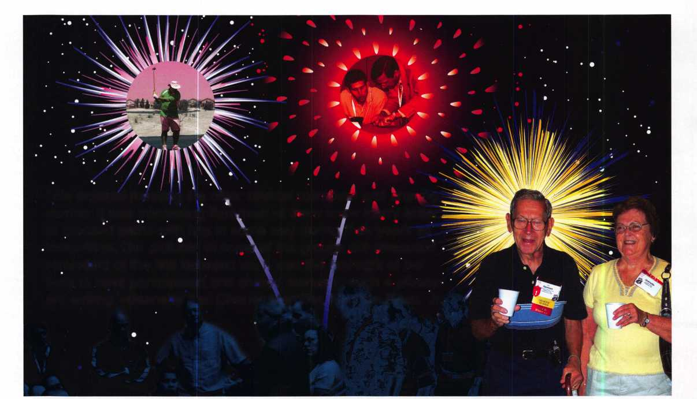

PACIFIC

P>



**CREATING MANUFACTURERS,  
ONE LOCKSMITH AT A TIME**

**Starting to lose your padlock business to the big retailer down the street? Realizing that special keys or keyways won't prevent your customers from leaving you for low prices? Then stop selling padlocks made by a manufacturer who is now directly competing with you by selling through big retail chains! Sell your customers a product that they can only buy from you...a PACLOCK with** THEIR **logo.**

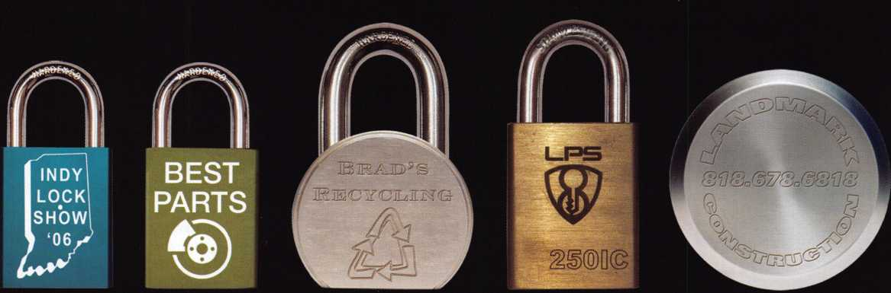

No *minimum orders*No *setup fees\**

*Guaranteed 10-business day shipping  
on ALL orders*

**r**

*Make money in ways you never could  
before by charging your customers for  
"your engraving service."*

**888.562.5565**

**[www.paclock.com](http://www.paclock.com)**

***"Your Logo*, *Your Locks™"*Pricing Example**

**Aluminum**

**$0.45**

**Brass**

**$0.75**

**Steel**

**$0.95**

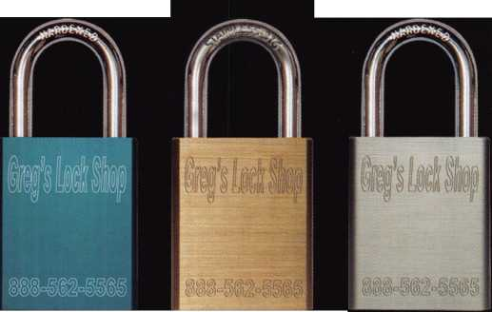

Give a Little Bit

by Greg Perry, CML, CPS

WMlIiM

I HI T

mmmum

WUiVWAI

cue

If you weren't at the 2006 ALOA  
Convention and Security Expo,  
you missed a great convention.  
One of the highlights for me was  
the opportunity to be a part of  
something new for ALOA. Jerry  
Newton, CML, owner of Ace  
Lock and Key of Las Vegas and  
ALOA's David Lowell, CML,  
CMST joined forces to find a  
deserving charity in the Las Vegas  
area who could use the help of  
our members. Instead of the nor-  
mal classroom hands-on instruc-  
tion, we took the class to the  
Assistance League® of Las Vegas  
for a day of good works.  
Organized in 1976, The  
Assistance League of Las Vegas® is

a chapter of the National Assistance League®. There, we installed  
five Von Duprin 9947 exit devices mated to OSI Security  
Omnilocks and an additional eight cylindrical OmniLocks.

Before we go any further, a few very public thank-yous are in order.

First on my list is OSI Security. Rick Rasmussen, Derek Trimble, Ron Seiss, and Adrian Acuna all deserve some major apprecia­tion. Not only did OSI donate all of their brand new WAMS (Wireless Access Management Solution access control hardware) but Rick also taught the morning class and oversaw all the instal­lations. Adrian and Rick spent two full days making sure the hardware performed properly. Altogether, they easily donated

over $30,000 in merchandise  
and time.

Jerry Newton, CML, CPS  
donated many hours behind the  
scenes setting up the install with  
Ron Seiss and The Assistance  
League of Las Vegas®.

The hardware schedule changed  
a few times during the couple of  
months leading up to the class  
but in the end Jerry had all the  
right hardware ready to install  
on class day. Jerry also sent two  
of his employees, Stan Pidcock,  
CML, CPS and Gary Goodhart  
to the Basic Electricity class on

day one and provided a third employee, Mark Austin, on day  
two while we installed all the hardware. During the entire proj-  
ect, Jerry stood in the background, modest about receiving pub-  
lic attention but he deserves a huge public thank you.

The Assistance League of Las Vegas® is a multifaceted charity for needy and deserving children. They help children in a number of ways; Operation School Bell® provides decent clothing to school- aged children. "The Kids on the Block" for third graders is pup­pet program to address many issues. "Operation Hug" provides teddy bears to police officers to give to lost or traumatized chil­dren. New this year is Project Smile. The Assistance League of Las Vegas® teamed up with the UNLV Dental School and Southern Nevada Dental Association to provide a day of dental checkups and education. ASSISTEENS® is a program in which Auxiliary mentor teenage girls. Another program they offer is

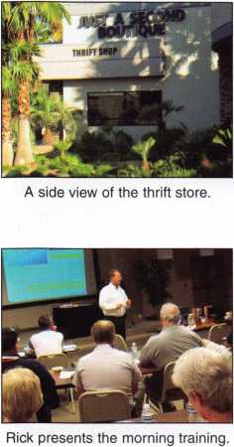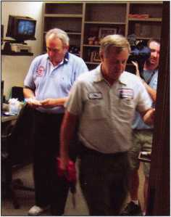

Stan Pidcock, CML, CPS installs the first lock on the door. In the background: Jerry Newton, CML, CPS and a cameraman from the local NBC news affiliate.

Keynotes • September 2006

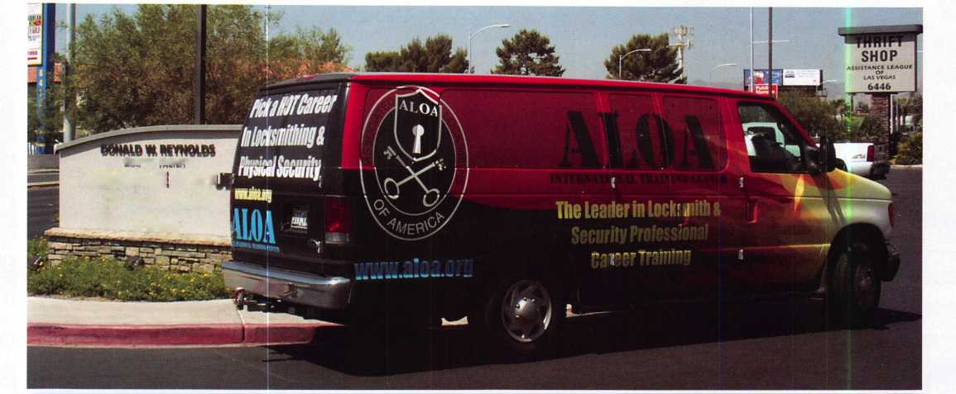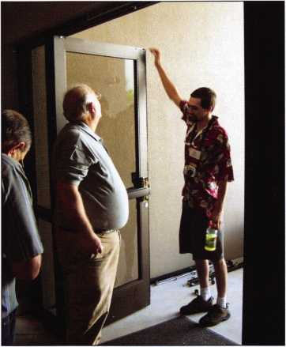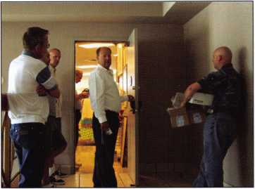

Rick Rasmussen directs the install of a cylindrical lock  
on the door between the thrift shop and the office  
area.The lock of choice for this door was a  
double-cylinder model.

"UR Special" that helps other groups. The Assistance League of Las Vegas® also provide Assault Survivor Kits® and operates a thrift shop. All of the employees are volunteers. They operate in Las Vegas out of beautiful building with hardware that was slowly failing.

A student crew looks at the outside aluminum/glass  
door. In photo 7 they are cutting the face of the door  
for the hardware.

on Mondays. This allowed us "free run" of the

The Assistance League of Las Vegas® offered their conference room to us and provided us with lunch and break- time snacks. They also contacted the local TV stations and newspaper to provide local cov­erage of the event. We showed up on Monday, the perfect day, since they are normally closed facility.

The project was created by David Lowell of ALOA who suggest­ed, "why not have the Electronic Access Control class install a full fledge access control system?" Most ALOA classes combine

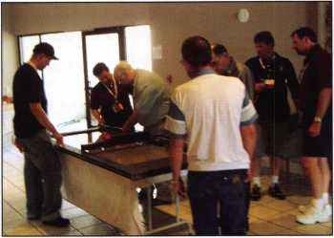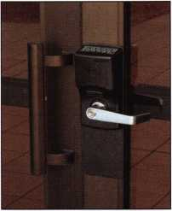

A student crew cuts the face off the door  
to accommodate the hardware.

But taking the class  
into a real-life situa-  
tion creates chal-  
lenges not always  
found in a class-  
room. Organizing a  
group of twenty-five  
students is also

challenging. There were also hardware  
issues to consider.

lecture, hands-on training or combi­nation of both in a classroom.

An outside view of the  
aluminum/glass door  
following the installation.

Photo shows a back door  
lock. The latch guard was  
modified to fit around  
the OmniLock

Cylindrical locksets from OS I install in standard lever-lock door preps, but the aluminum glass doors with wide styles at The Assistance League of Las Vegas® presented some challenges.

Von Duprin 9947 concealed vertical rod exit devices were chosen. This choice was made even though there were Adams Rite devices already on the doors, because OSI offers an out­side trim to mate with the exit device. The alternative solution was to install a wall-mount reader and either use an electrified exit device with a separate power supply or use a different brand with an electrified trim. Jerry Newton, CML, CPS made the final decision, choosing Von Duprin to avoid running wires through the door and in the wall because the city of Las Vegas requires all wires in a commer­cial building to be installed in con­duit.

The students in the class divided into teams to install the hardware.

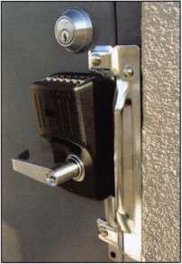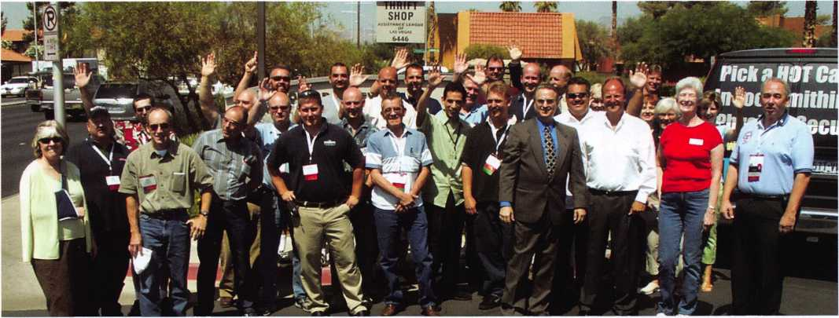

Keynotes • September 2006

a pair of different portal gate-  
ways. These are the radios  
that communicate with the  
locks.

We ran into a few problems during  
the day. The door modifications were  
the first problem, although Jerry  
quickly created a solution. The next  
problem dealt with the new hardware  
network. OSI encountered some

issues with the wireless access hubs. One of the access ports from  
the other side of the building was acting like as a "super" port.  
Adrian and Rick were able to solve the issue and I think they  
were grateful to see the problem in the field. It helps when the  
senior tech support specialist can see some of the problems that  
we might see in the field. As a side note, seeing the factory guy

Installing the devices required some  
modifications to the door inside the  
style. The web between the top rail  
and the inside edge of the style need-  
ed to be cut away to mount the top  
latch. Stan Pidcock, CML began by  
cutting blocks for spacers inside the  
top rail. The race was on to see who  
could install the hardware the fastest  
and cleanest but at the end of the day  
the ultimate winner was The  
Assistance League of Las Vegas®. All  
the doors to the main building were  
completed and Jerry sent a couple of  
his guys out to finish the last door on  
Tuesday.

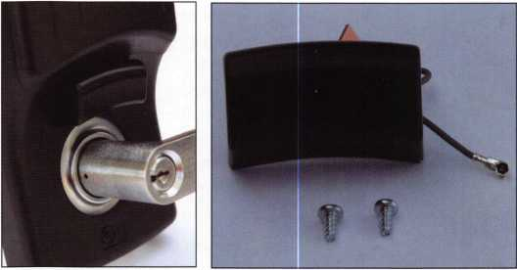

The radio array (antenna) can  
be seen above the  
lever rose.

Photo shows the array outside the lock.

Photos show the electronic boards. The locks use  
4 AA batteries.

have a little  
trouble gives  
me a boost  
of confidence  
when I'm  
out on a job  
and things  
don't seem  
to being  
going right.  
It's nice to  
know I'm  
not alone.

A few notes about WAMS: it only runs on the Microsoft Windows XP Professional or Windows 2000 operating systems.

It can support different card technologies in the same system. The wireless communication is kept secure with 128-bit encryp­tion. The software supports multiple time zones for those sys­tems running with readers in multiple parts of the country or world. Omnilock developed a unique way to monitor door posi­tion through a magnet built into the strike screw. Combined with the internal REX (Request to Exit) the door-position switch can monitor for a forced-door condition and will send an alarm if the door is opened without the inside lever being turned or outside credential being presented. The lock can also notify the host computer when a key was used to gain entrance.

Overall, the class was well received by students. Being able to actually install hardware and provide philanthropic assistance at the same time gives a person a nice feeling. The Assistance League of Las Vegas® is in the business of helping others but this time we were able to help them.

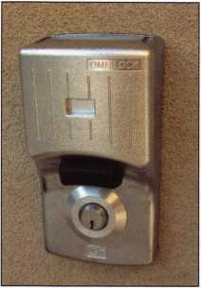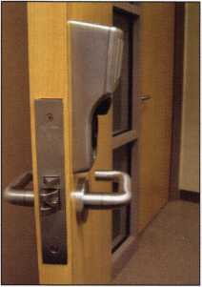

This is a wall-mount unit. The  
Medeco cylinder (seen where  
the lever spindle is) normally  
locks the housing to the  
back plate.

The WAMS Omnilock solution is a  
unique product. First it is a stand-  
alone self-contained access control  
product. It is available in four basic  
forms: cylindrical, mortise, exit  
device, and a wall-mount reader  
available only for use with separate-  
ly-supplied electrified lock such as  
an electric strike or electrified exit  
device. Features normally found  
only in a full-fledged hardwire sys-  
tem are built into this product. The  
locks operate with or without input  
to and from the main control com-  
puter. Each reader can handle up to  
65,000 credentials or badges, 144  
user-defined time zones, and 32 dif-  
ferent holidays. Many different card  
format readers are available and the  
keypad offers the option of card-  
only access, PIN-only or card access,  
and PIN-required access. If the soft-  
ware is running on the server (host  
computer) and the portal gateway is  
connected either to the local com-  
puter network or the Internet you  
have two way communication just  
like in a hardwired system. The  
huge advantage is the lack of wires.  
This setup removes the need for an  
electrician run conduit and wire,

depending on local city requirements. A traditional hardwire sys-  
tem can easily take 4 to 10 or more hours per door to install the  
lock and wire. A traditional system may require separate power  
supplies near each door. The wireless connections also remove an  
objection to the original Omnilock that required taking a hand-  
held computer with an infrared port to communicate with the  
reader.

OSI also produces a mortise lock version.

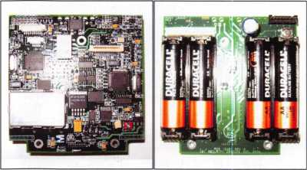

**6**

Keynotes • September 2006

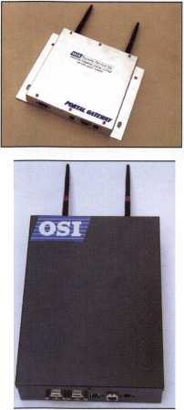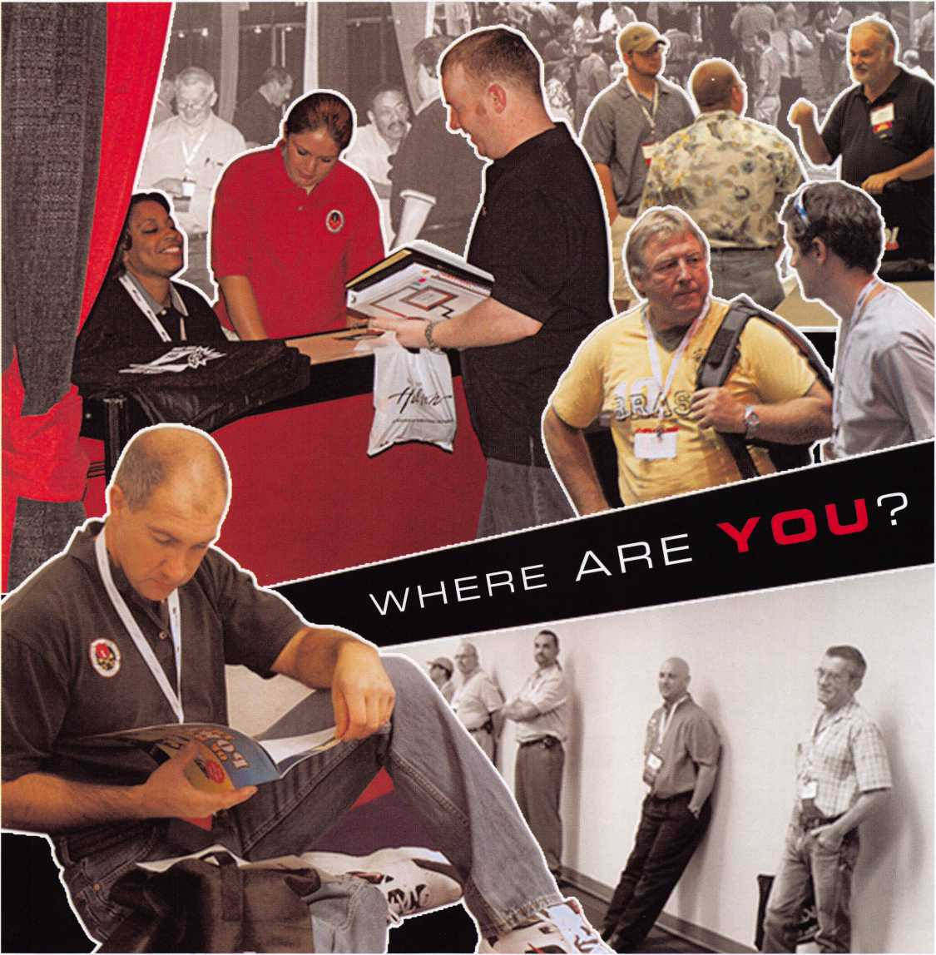

PHOTO WRAP-UP!

Keynotes • September 2006

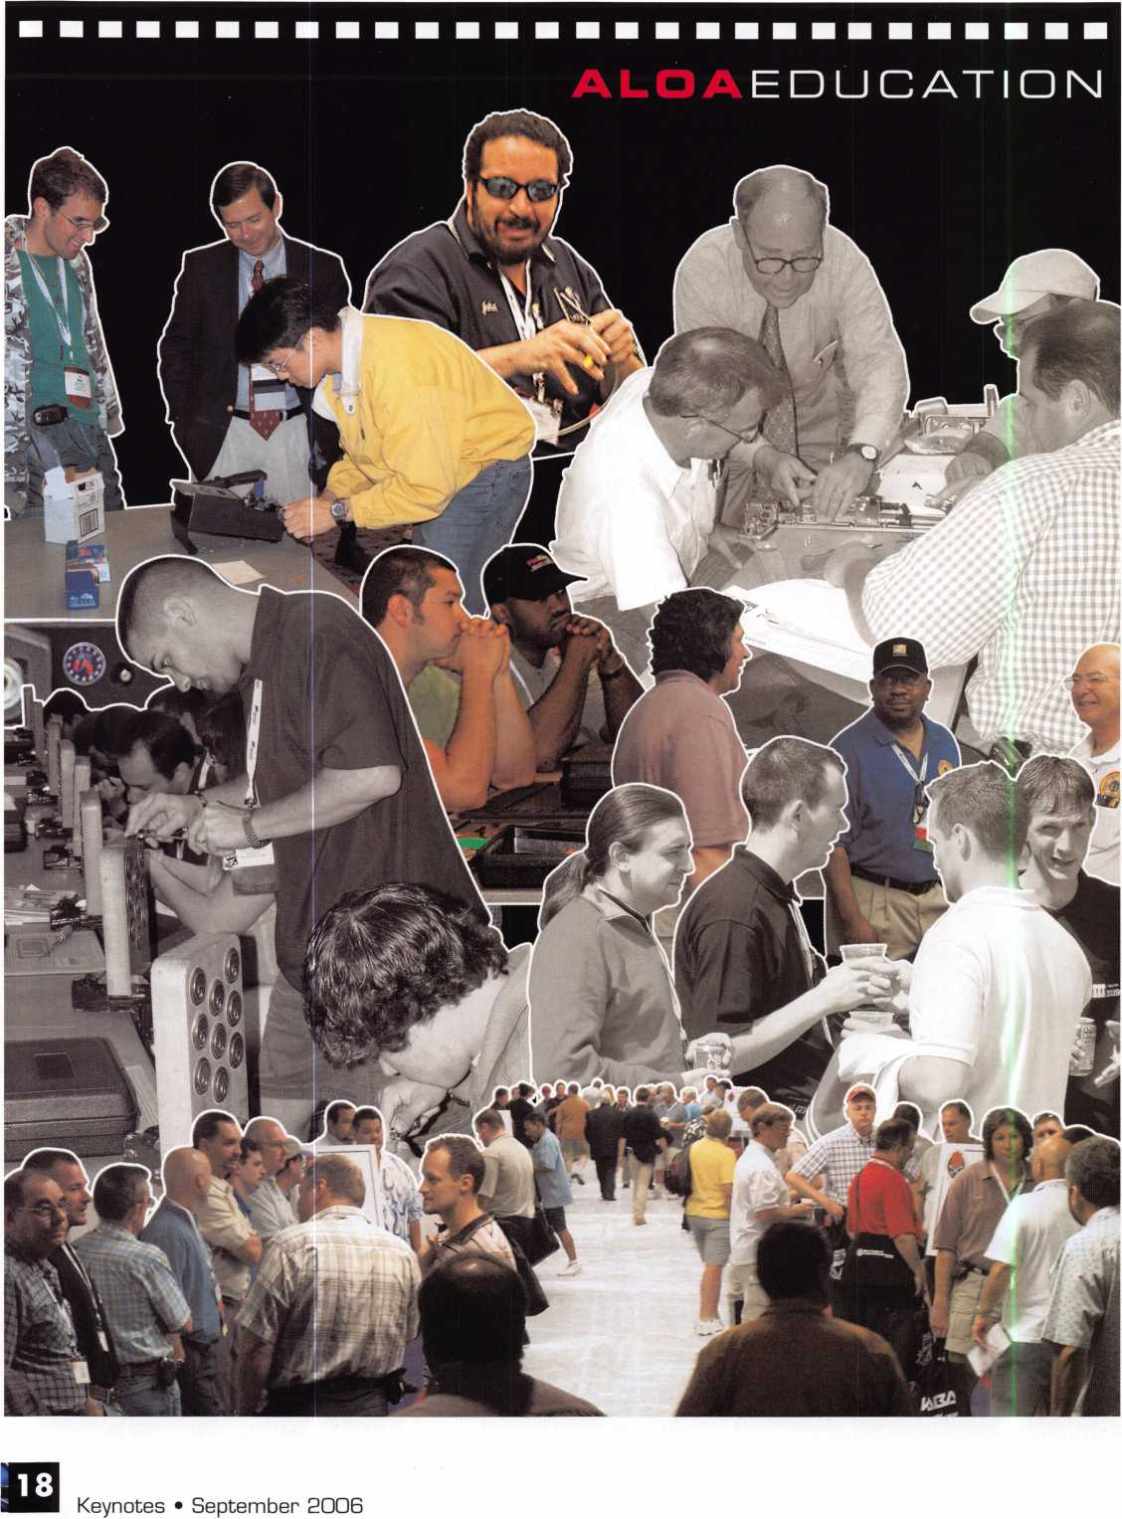

tersoll Rand

Real Security Is When Do-Overs  
Take Place Only On Your Personal Time

When you install Schlage® locks, you know you've done the job right. After all, our products are among the most durable and dependable on the market today. They're also easy to install, repair and maintain, so they generate fewer callbacks. Which means you're free to concentrate on other things. Like learning how to pick up the 7-10 split.

Real Security Sets You Free1

**www. schlage. com**

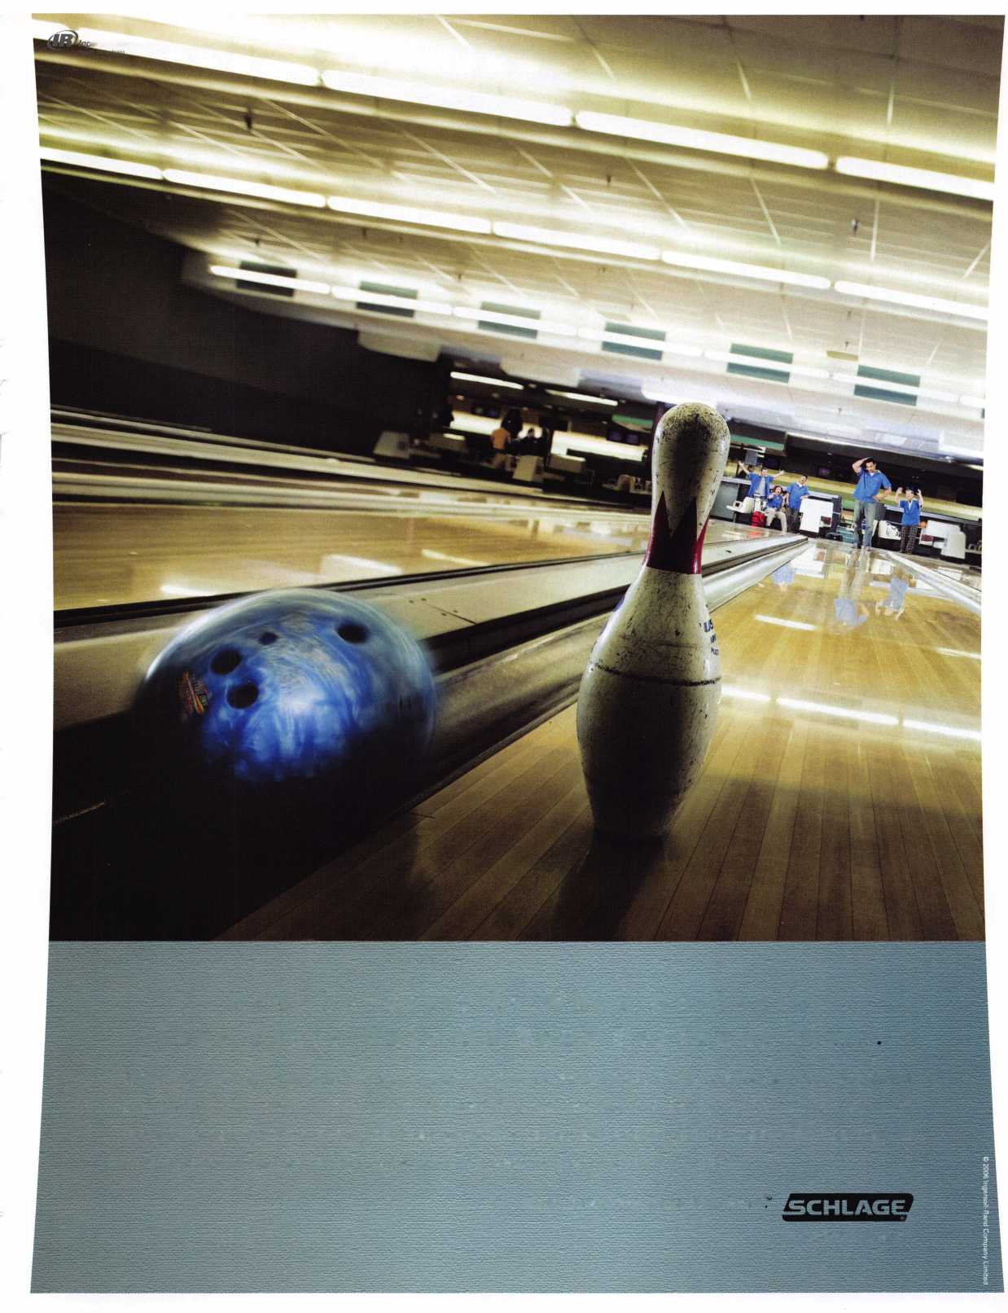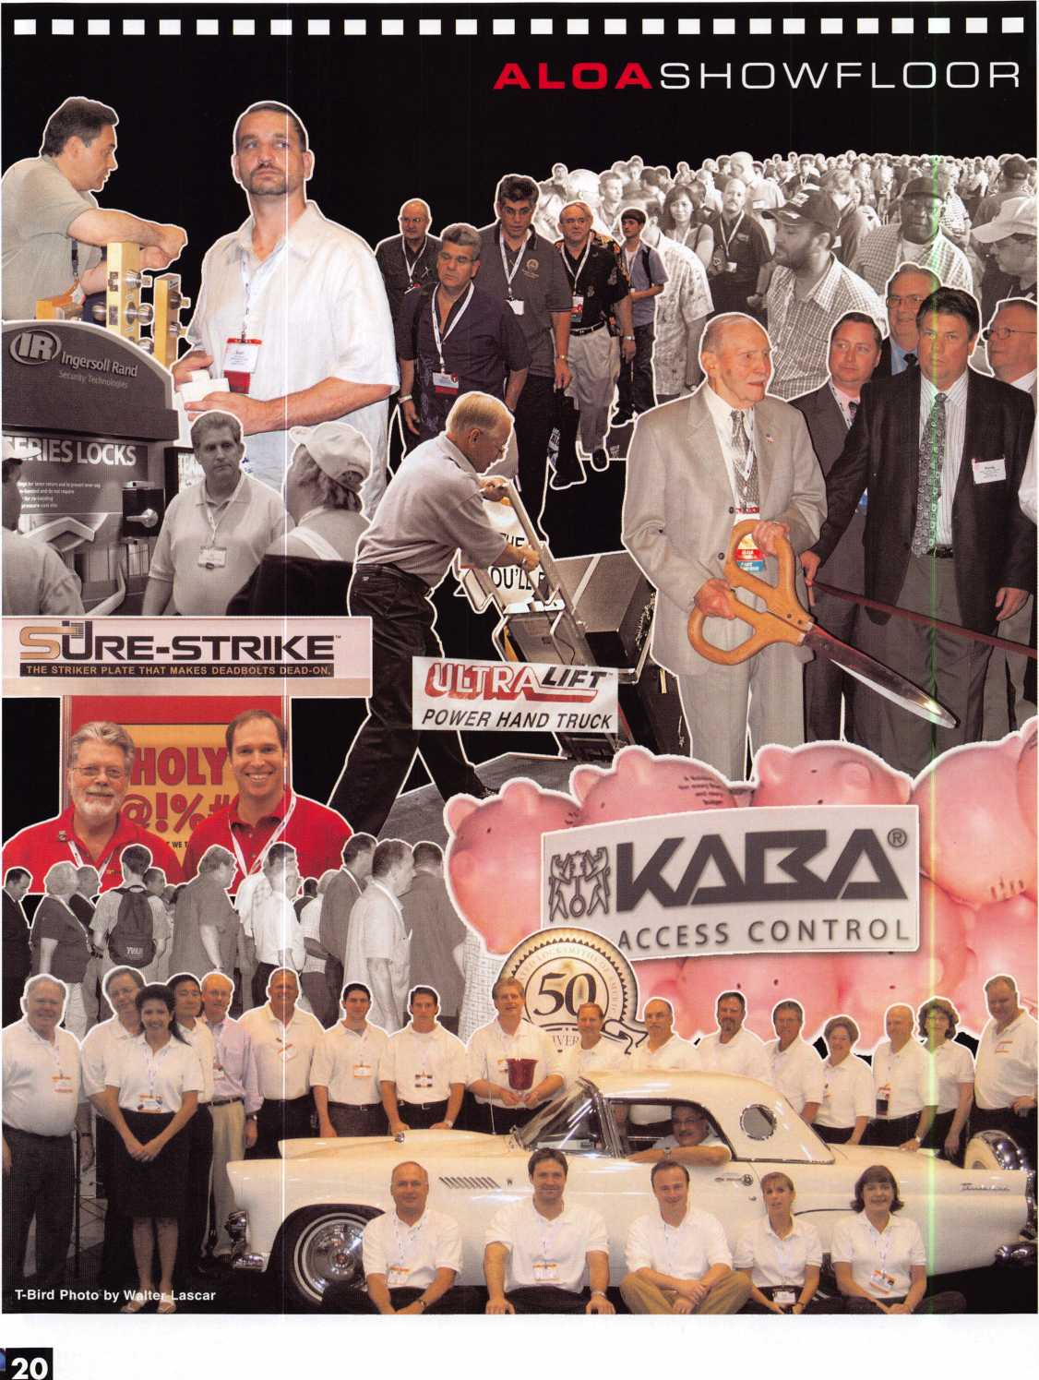

Keynotes • September 2006

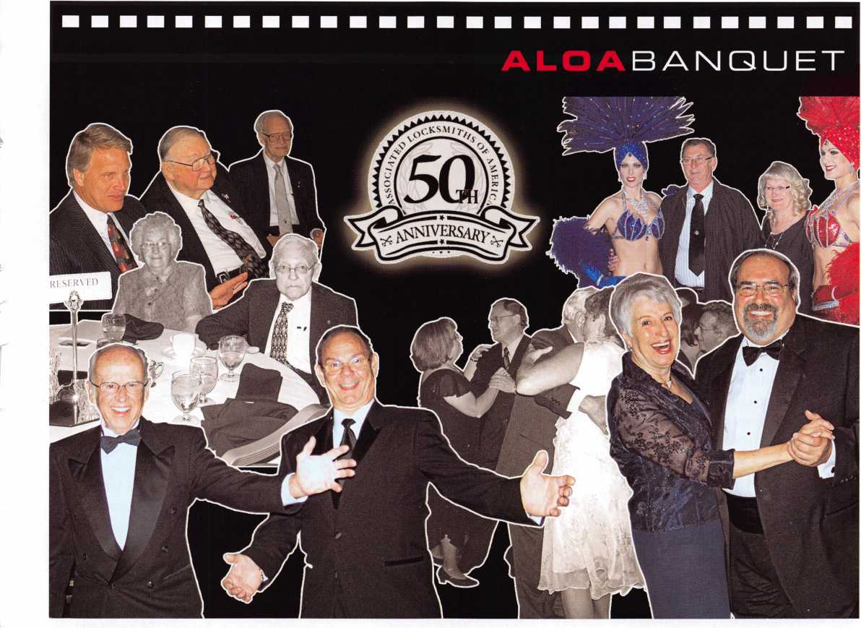

You need it When?

How about now!? :-)

☆

ClearStar

etwork

Another Special  
Value-added Benefit to your

ALOA Membership! Click here

lL

[www.clearstar.com/ALOA](http://www.clearstar.com/ALOA)

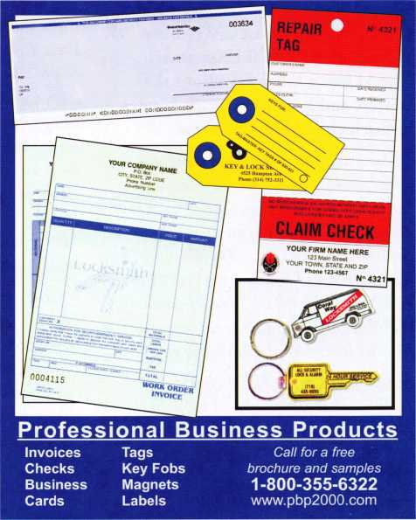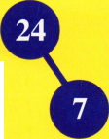

Kaba Picks a Winner

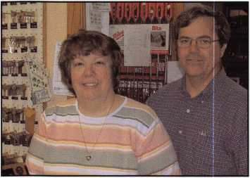

The winner, Cheryl Anthony with husband, Doug, owner of A-1 Brown's Locksmith & Hardware in St. Joseph, Ml

Kaba recently picked a winner in the "You could win a Trip to Vegas & Ultimate Lockshop Package" sweep- stakes. The winner, Cheryl Anthony received the "Ultimate" package from Ilco - estimated Value $27,000 (US) plus airfare and hotel accommoda­tion for three days at ALOA 2006. Cheryl grew up in the locksmith business, working with her grandfa­ther Paul M. Brown. She attended her first ALOA show in 1964.

Cheryl’s mom, Edna Sernau (age 81) still works at the shop everyday! The contest was conducted by the inde­pendent firm Centra Marketing & Communications, LLC Westbury, NY. When interviewed for Keynotes, Cheryl had a lot to say about the contest and her family’s rich history in the locksmithing business.

I found out about the contest one day while reading one of the Keynotes and came across an ad about this contest that Kaba Ilco was putting on for the 50th Anniversary of ALOA. The Grand Prize was airfare and hotel for the ALOA show AND $27,000.00 in prizes of wonderful machinery! The requirements for entering left any locksmith the ability to enter.

My husband and I had a class at H. Hoffman Co. that night. I brought the ad and talked to Chris Orme about it

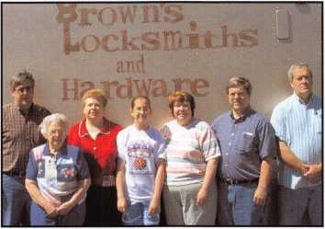

It's a family affair! (L-R) Ray Sernau-Cheryl's brother, Edna Sernau-Cheryl's mom, Lori Shank-Cheryl's sis­ter, Emily Shank-Cheryl's niece, Cheryl Anthony,

Doug Anthony-Cheryl's husband,

Terry Young-Cheryl's cousin

and he encouraged me to enter. He said the odds were wonderful! Look at the odds on a scratch off lotto ticket for a 27,000 dollar winner. The machines are the most advanced and highest tech available. He knows our shop and said if we won it would make our life a lot easier. The plane fare and hotel was an added bonus.

I did not get the entry in until the last minute because we have been so busy. Chris stopped to visit and asked if I sent it in and I said no. He encouraged us to send it in now! I did as he said.

The day I received the letter stating that I was a potential winner of the Grand Prize I was ecstatic! It was a dream comes true. I walked into the store and everyone knew I was excited about some­thing. I couldnt get the corners of my mouth unhooked from the top of my ears for a week. I was on cloud 9! I told everyone in the store and called Chris at H. Hoffman Co. in Grand Rapids, Michigan and told him. He was as excit­ed as I was!

I thank everyone at Kaba Ilco for this Great prize and for all the support they have given the locksmiths and ALOA since the beginningr! I cant imagine a convention or trying to operate a lock shop without Ilco as a support, a standard for the industry, a supplier of product and



Cheryl at the 1966 ALOA convention from a program "compliments of Independent Lock Company"(ILCO)

reference material and quality machines. Our shop owns Ilco machines from 40 years ago to current models that are still running and MAKING MONEY every day.

My locksmith career started when my Grandpa Brown needed some help down at his shop. I was 13yrs old and my brother, Gerry, was 11. We would walk down to the shop during the summer and start learning the trade from grandpa. Little did we know that this would be our lifes profession! My little sister Lori would sleep in a box in the back room for her nap while mom did the book work.

Grandpa looked forward to attending the ALOA conventions every year. He want­ed to see what was new and coming out that year. He liked seeing the people that he ordered from on the phone. He made many new friends like Gibb and Coral Erdman of Howard Safe in Detroit.

My first convention was in New York in 1965. My mother, brother, grandpa and I attended. There was so much to see and learn! Gerry and I attended our first class, Young Locksmiths, taught by Harry Miller from Sargent and Greenleaf Mr. Miller was a fantastic teacher and taught us many things. One important thing I learned, that I still practice today, is to acknowledge someone when they come into the store even if I am with another

Keynotes • September 2006

**East**

**Pennsylvania 1-800-233-4210 Fax: 1-800-854-4146**

**West**

**Nevada**

**1-800-722-4210 Fax: 1-800-248-3620**

That’s just one way we prove that We Know Service. Top Notch also offers you the architectural hardware industry’s most complete product inventory, the expertise of a staff with an average of 15 years of experience, 1272 hours of highly personalized support a day and three strategic distribution points.

Now, we’ve taken We Know Service one step further with a customer support program called TND is Me! Because fulfilling all of your needs and expectations really comes down to a one-to-one relationship.

“You and me, partners in success.”

**Midwest Missouri 1-800-211-4607 Fax: 1-800-211-4608**

Top Notch has set standards in our industry by achieving the highest levels of customer service. We personally check and recheck every step in our process, making sure that your order is defect-free, complete, safely packed and optimally routed to you. In our industry, no one can match our same-day shipping and 99%+ order accuracy rate!

**[www.topnotch.bz](http://www.topnotch.bz)**

**[sales@topnotch.bz](mailto:sales@topnotch.bz)**

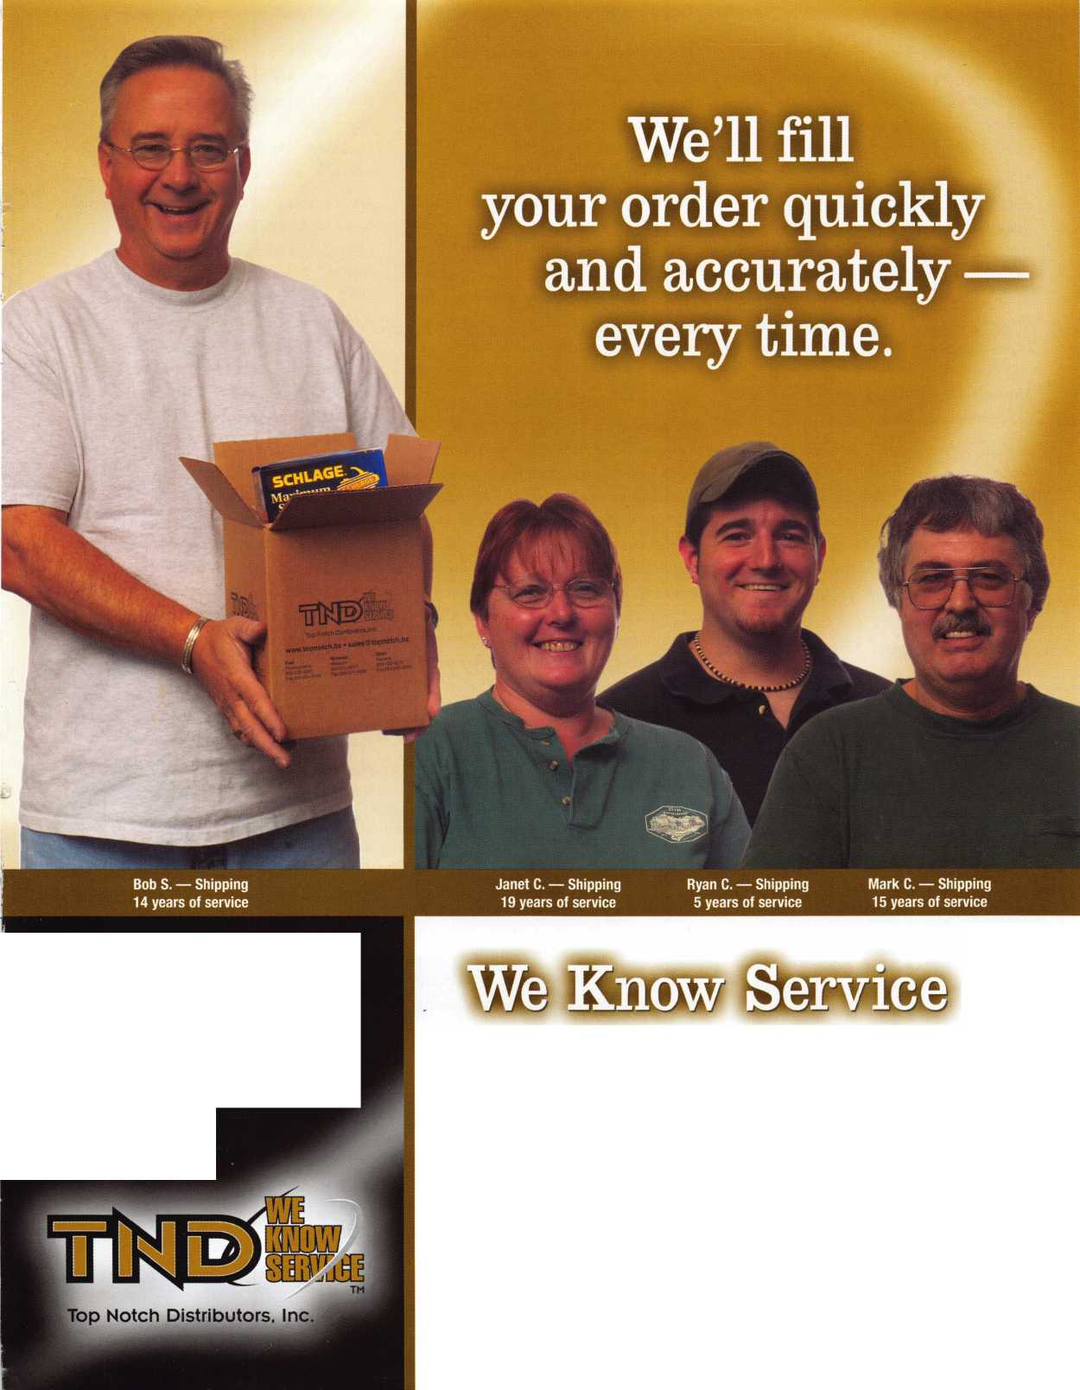

customer at the time. This lets them know they are important to me and also lets another employee (or in my case another family member) know there is another customer in the store.

We have many people who have become good friends like Chuck and Betty Saunders of Westland Lock and Key. As the years went by our acquaintances and friendships grew. Talking to others in the trade educates you so your work improves, thus improving the trade as a whole. I hope in years to come that this educating and bonding of locksmiths continues. We have always eagerly anticipated each new convention will be!

In 1967, the show was in Chicago. My brother, grandpa and I attended classes so we flew to Chicago early in the week. My dad, mom, 2 other brothers and the youngest, my sister, drove in to attend the banquet and attend the convention.

Grandpa liked to deal. He and Murray Kramer dickered back and forth until Grandpa Brown won. Grandpa once bought the entire MD Kramer booth for $2000.00! What a trip home! We all will always remember it! Why? When you are one of eight people in a 1960 Chevy station wagon with $2000.00 worth of key machines and merchandise, you you cant forget it! The rear springs were fully compressed to the rubber stops. The tailgate was open and loaded! Try riding in that for 100+ miles and you will have a memory that lasts a lifetime!

ALOA continued being an important part of my life even on my honeymoon. I got married in 1971 on July 31st. My hus­band and I spent the first week traveling to Niagara Falls and driving south to Washington D. C. where we had our first disagreement. Then we moved on to, you guessed it, the ALOA convention in Atlanta, Georgia for the second week of our honeymoon! I broke my husband in right with a couple of classes and endless walking on the show floor.

Our daughters always knew where our next “vacation' was going to be. They only had to look at a copy of Keynotes to figure it out. Disneyland in California, Kansas City, MO, Disney World Florida, Kings Island Ohio, Fort Knox-Mammoth Cave Kentucky and Six Flags Illinois are places they will always remember. Hopefully they will also remember the city names too!

ALOA and locksmithing have brought us many places we could never have gone otherwise and has been at the center of my entire family's life.

My father helped move safes for grandpa and us. He was always there to do car­pentry work or help mom with state­ments. He passed away last summer. Mom still keeps us in line at a young age of 81 every day at work! If she is on an errand, customers miss her! My nine- years-younger sister, Lori, does bookwork, receiving, pricing, stocking, customer serv­ice and watches where I lay my books down to keep me in order. My youngest brother does customer service, lock work, in-the-shop- orders, hardware, and accounts receivables. My cousin does out­side and inside lock work and fabricates things for safes, locks and etc. in his home machining shop. My husband works on the road day and night and my nieces, Emily and Katherine, help out during the summer months. They are the forth gen­eration working in our shop!

The favorite part of my job now is selling decorative hardware. Construction has been booming these last few years and we created a nitch for ourselves by servicing contractors with upper scale hardware.

We let Lowes and Home Depot do the inexpensive!competitive stuff. We sell Rocky Mountain, Baldwin, Omnia, Schlage, Emtec, Bravera, Kwikset. Ironmonger and any other brand an architect may specify. We also provide towel bars and towel warmers along with tons of cabinet pulls.

**24**

We refer jobs we are unable to do to those who can. My brother, Gerry, owns Berrien County Locksmiths and does heavy safe moving and commercial lock- smithing. Michaels Locksmith gets daily referrals.

Locksmithing is changing so fast it would be impossible to keep abreast of the changes without an organization like ALOA. I remember the 35-cent key and the five-do liar service call. Who would have ever thought a car key would eventu­ally cosst $100.00? Simplex has been around since I was young and has set the standard for all others. Now, how many hundred access control locksets or methods are there?

Many things have changed over the years. Remember when people bought for quality? Now, they are more concerned with price. If a purchase doesn't last it's not important! Throw it away and get a new one. So the consumer dollar often goes towards the item with the best appearance or the one offer­ing the biggest sales promotion.

What doesn't change? Service! If we on the retail level strive to do the best job we can to get the customer what will serve his needs and abilities best, the price we charge will be appreciated and repeat sales will follow.

If we use and work with our suppliers and learn from them, sales will improve.

I will always be thankful for my suppliers: from Al Hoffman who cosigned the loan for our new store equipment and stock to Gene Simon, Ramo Beletini, John Colianne, Ken Grob and all the other wholesale suppliers and manufacturers reps who have come to our aide to educate and assist with sales and product. We all work together to help make each other rich in friendship, knowledge and pocketbooks.

Keynotes • September 2006

**This year we’re back in LEXINGTON for the 150th Anniversary of Sargent & Greenleaf.**

Keeping up with the latest the industry has to offer has never been this important - or this FUN! When it comes to learning about the latest in safes and vaults, time is of the essence. SAFETECH 2007 fea­tures an all-new menu of classes, covering every safe topic on the globe.

***OUR SAFETECH 2007 SPONSORS!!***



**SARGENT AND GREENLEAF®**

***THE RACE STARTS HERE***

**SAFETECH**



**LEXINGTON’S**

**READY.**

**ARE YOU?**

**MARCH 5th thru  
MARCH 10th, 2007**

**LEXINGTON**

KENTUCKY

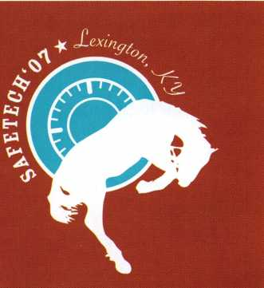

Behind the Green Label

by Greg Perry, CML, CPS

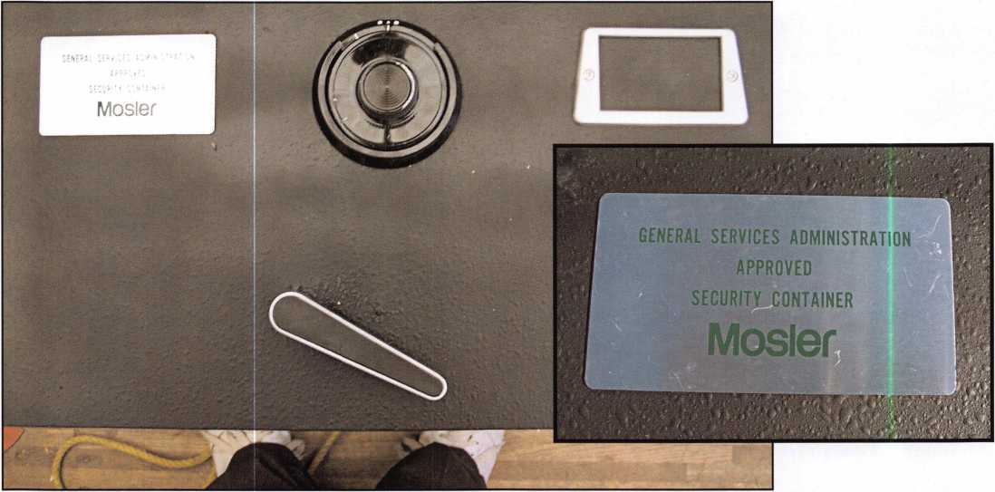

What’s behind the Green Label? An out of town customer called, it seems their X-07 lock stopped working and the local locksmith had removed the dial and cables but couldn’t get the safe open. Can I open it and how much? The cus­tomer had already done some research to determine the Green Mosler label indicated it was a GSA Class 7 safe. I quoted a price and set a date to go open it.

So what is a Class 7 file safe? The first thing to notice about a Class 7 is the weight. It only weighs about 360 pounds. Built for storage of classified and secret it was meant as a lower cost alternative to the Class 6 file safe that can be used for top secret storage and weigh around 600 pounds. It also as explained by Vaughan Armstrong in several Safe and Vault Technology articles from the 1990’s was designed to replace all the file cabinets with locking bars and padlocks. The Federal Specification AA-F-2815 for the Class 7 safe was effective November 16, 1992 and canceled November 22, 1995. The requirements for the Class 7 were; a lock meeting FFL-2740 (at that time an X-07), 15 man-minutes against

covert entry, 20 man-hours of surreptitious, and no forced entry. So why does the different weight matter? Less weight means less steel, less steel means less to drill, right. Does that make it easier to open? Not really. The problem is the skin of the drawer front is only .080 thick, the Class 6 is

.125.  
Thinner  
material  
means fewer  
threads to  
grab with  
the mount-

PROTECTION

Thic reaUS Government Class 7 cabinet

protection:

15 man-minutes against covert entry. 20-man-hours against surreptitious entry No forced entry requirements.

MOSIER INC.

S!S: *»»>“

TO RELEASE DRAWER BOLTS PUSH LEVER ►

mg screws  
for the  
StrongArm  
MiniRig.

The second

problem with the drawer front is the distance between the front skin and the carbide-included hardplate box. The gap is close to .0625 or about 1/16”. The screws that come with



Keynotes • September 2006

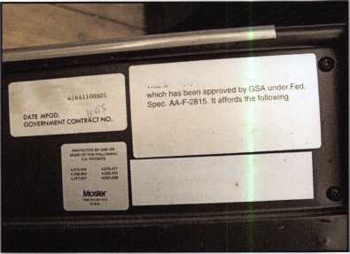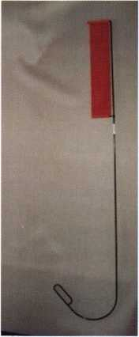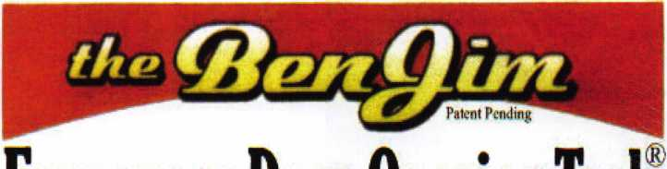

All commercial buildings have two things in common:

* Fire code requires that all commercial locks open by a single action.
* The American Disability Act requires free access through doorways,  
  which leaves a gap between the door and the floor.

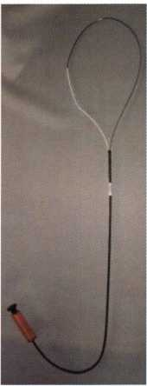

Knoblock Tool

Leverlock Tool

WITH THIS IN MIND WE HAVE DEVELOPED THE TOOLS REQUIRED TO EFFECTIVELY  
OPEN DOORS QUICKLY AND WITHOUT DAMAGE

Designed for interior commercial doors

For knoblocks, the tool is slid under the door with no cords to pull or get tangled.

For leverlocks, a similar tool is used by applying the same method of sliding the tool under the door and pull until the lever retracts.

Both tools are designed to work with very little effort, excessive force is not needed.

Visit our web site at [WWW.THEBEN-JIM.COM](http://WWW.THEBEN-JIM.COM) for more details.

THE BEN-JIM KNOBLOCK TOOL $ 99.00

THE BEN-JIM LEVERLOCK TOOL $ 79.00

SET (one each) $ 169.00

PLUS SHIPPING & HANDLING

**TO PLACE AN ORDER CALL 1-586-778-1911 OR VISIT US AT [WWW.THEBEN-JIM.COM](http://WWW.THEBEN-JIM.COM)**

MADE IN THE U.S.A BY THE BEN-JIM CORPORATION.

24711 Harper Ave.

St. Clair Shores * MI * 48080 * (Fax) 586-778-0530

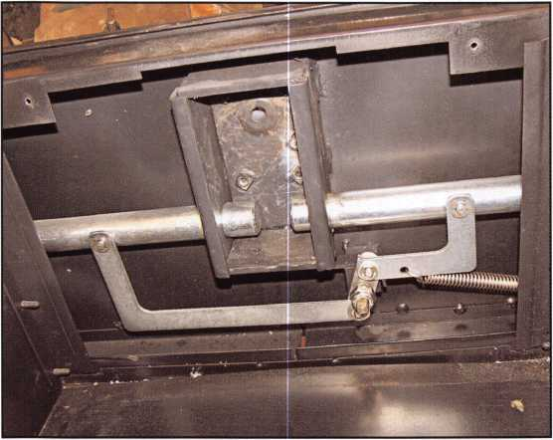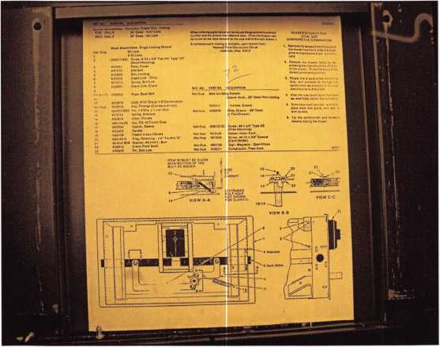

the MiniRig were too long, I carry short screws but each  
time I tried to put any pressure against a carbide bit it pulled  
the bottom screw out of the hole. I tried to thread the other  
dial ring mounting holes with a bottom tap. About the time  
the threads would start the tap would bottom out against the  
hardplate. I finally ended up drilling the hardplate with dia-  
mond core drills only. Normally I drill carbide-included  
hardplate alternating between diamond core drills and car-  
bide drills to clear the hole and reduce the friction on the  
inside of the core drill. This is a safe that was screaming at  
me to use a vacuum press. Although the hardplate was only  
1/2” thick it took over two hours of very slow drilling. By  
comparison usually I can drill 3/4” of carbide included in a  
Red Label safe in less than 45 minutes.

This customer as mentioned earlier had done his homework.  
He works for a government agency that salvaged or trans-  
ferred the safe from another agency and it came with the  
MasHamilton X-07 lock already on it. He had already  
determined since this he was storing confidential but not  
classified materials the lock needed was a Group 1R mechan-  
ical combination lock. The repair consisted of a carbide plug  
welded on both sides and an S&G 8460 lock installed after  
the drawer front was repainted.

Other than the difference is weight, meaning a lighter gauge  
of steel the basic construction is the same as other Mosler  
Class 6 file safes from the mid 1990s. This cabinet accord-  
ing to Vaughan is rare but you may find one in the field and  
if you do you’ll now know what is Behind the Green Label.

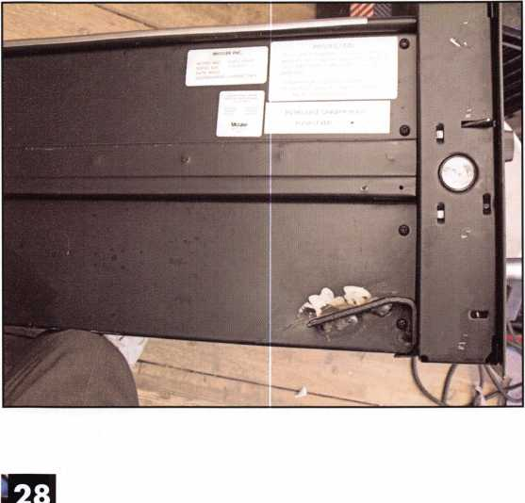

Keynotes • September 2006

**Latvian Locksmith Brotherhood & European Locksmith Federation present**

**European Locksmith (ELF) Convention 2007**

The annual convention of the European Locksmith Federation will be held from May 18-20, 2007, in Riga Central Hotel Reval Hotel Latvija. This is where the leading locksmiths from the European and American continents will be gathered together.

The objective of the Convention organized by the Locksmith Federation is to promote the exchange of experiences, demonstrate the most recent successes and achievements, to provide training seminars and workshops for the members of the Convention, to organize exhibitions of products of the leading compa­nies in the world as well as to introduce lock­smiths with the host country of the event.

**Comprehensive exhibits for professionals and workshops are planned.**

Main topics: SAFETY OF RESIDENCES, OFFICES AND VEHICLES AGAINST BUR­GLARY AND IN CASE OF EMERGENCY EVAC­UATION, NEWEST TECHNOLOGIES AND EU REGULATIONS.

For information & applications:

Ruta Reinika

[ruta.reinika@prplus.lv](mailto:ruta.reinika@prplus.lv)

[www.elf2007.com](http://www.elf2007.com)

1*

**VingCard**

**Elsafe**

Secure Your Future

With the Market Leader in Electronic-Locking Systems

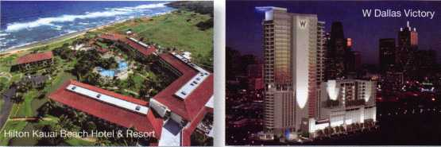

**Qualified Locksmiths Wanted...**

We are looking for locksmiths to contract with to install and service our security solutions.

Large-scale installs, steady workflow and professional training are some of the many benefits provided.

***Call: (800) 225-8464 Ext.*** *3127*

VingCard Elsafe - 631 International Parkway, Suite 100 - Richardson, TX 75081 - Toll-Free: 800.225.8464 Phone: 972.907.2273 - Fax: 972.907.2771 - E-mail: [noram@vcegroup.com](mailto:noram@vcegroup.com) - Internet: [www.elsafe.com](http://www.elsafe.com)

An ASSA ABLOY Group company **ASSA ABLOY**

Service Standards:

The Key to Becoming Like the Business You Love

by Marsh Lindquist

Your service standards are your personal corporate statement about what your organization does and how it does it, whether you produce services or products. In other words, its a statement of your business’s service philosophy or atti­tude. While businesses commonly state their service stan­dards to their customers and prospects by posting the stan­dards in public places and in marketing materials, you need to state your standards internally, too, and get full buy-in from everyone in your organization. If your internal stake­holders don’t fully understand and practice your service stan­dards, stating them for external stakeholders will be a mean­ingless exercise.

What is a service standard, exactly? One very successful busi­ness’s read: “We will endeavor to greet people in the way we want to be greeted. Once they’re with us, we will treat them with respect and the knowledge that they know our business almost as well as we do. In return, we will expect to get the kind of feedback that will allow us to continually improve

and change anything that is not working in our organiza- • » tion.

Many organizations already have service standards, but most don’t actually practice them even intermittently throughout the organization. Your service standards need to be a part of the business’s fabric, and those running the organization need to make the standards something their people do on a regular basis.

When you’re developing your own service standard, it must focus on your customers and how you want to treat them. You want your customers to have an expectation that they’re going to be treated a certain way. Three types of standards exist. Which of the following is most like your organization? Which would you like to be?

* Celebrity Red Carpet Standards: Businesses that live and breathe their high service standards make you feel like an award-winning star at every turn. When you’re looking for highly-polished, flawless service, you know you can go to this kind of business, the creme de la creme of hotels, for example. You know you’ll find real attention to detail, and that everything will be done well because everyone throughout the entire organization, from upper manage ment to the people who clean the brass in the hallways, understands what they’re delivering. They are there to serve you, first and foremost.
* Yellow Brick Road Standards: These kind of businesses will take you where you need to go, but without the bells and whistles. They deliver good value, and are efficient at what they do, but there’s not much attention to detail. It may be a restaurant that you know you can count on for a consistently good meal, but not everyone there greets you, and the staff seldom go out of their way to ensure you a complete dining experience. They take care of busi ness, and that’s it. If something goes wrong, they’ll take care of it right away; they’re service standards are to satisfy the customer by delivering what you ask for, but they rarely go beyond that.
* Welcome Mat Standards: The philosophy of this sort of business is “We’re here to get the job done. How you’re treated is really not that important to us.” People who work in businesses like this may have personal standards they try to implement, but they are not enforced uni formly throughout the organization. It’s not uncommon to find that these businesses have declared themselves to have service standards, but the people in the organization don’t know what those standards are, and therefore they don’t know what’s expected of them. When they’re hired, they are likely to hear: “Get the job done,” and little else. They’re untrained in how to treat their customers and give no attention to the value of what they deliver.

**30**

Keynotes • September 2006

**2006 Pacific Locksmith**

**CONFERENCE**

**October** 10**-**14**,**2006

**Portland,  
Oregon  
Holiday Inn**

**(A I R PORT  
LOCATION)**

Classes

o **Servicing Aluminum Storefront Doors** o **Basic Locksmithing** I o **Basic Automotive Locksmithing** o **Hollow Metal Doors and Frames**

o **Basic Locksmithing** ll o **Intermediate Automotive Locksmithing w/L**-03 PRP

o **Exit Devices & Exit Alarms w/L**-16 PRP o **Master Keying** I o **Advanced Automotive Locksmithing w/l**-04 PRP

o **Professional Lock Picking Techniques** o **Life Safety Codes w/ L**-07 PRP

o **Master Keying** II o **Motorcycle**

**Locksmithing w/L**-22 PRP

o **Defense Against Methods of Entry** o **(Alternative Entry Techniques)**

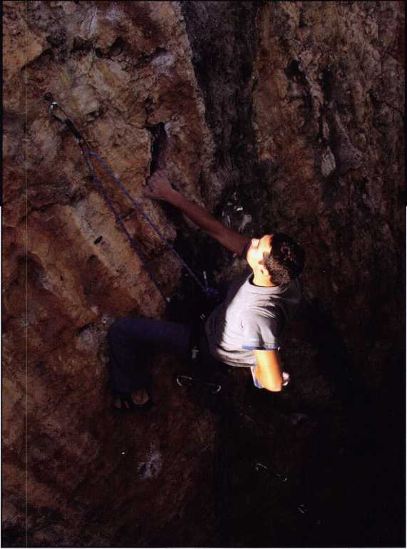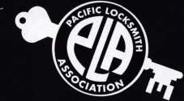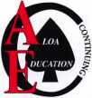

* ACE CLASSES
* 2006 STATE  
  PROFESSIONAL  
  LOCKSMITH DAY  
  BANQUET
* **Seminars**
* **PRP Exam**
* **Trade Show**

**Are YOU READY TO TAKE  
YOUR BUSINESS TO THE**

NEXT LEVEL?

BILL BOTEK, CRL • 503-644-988 1 • [BBOTEK@PRECISIONLOCKSMlTH.COM](mailto:BBOTEK@PRECISIONLOCKSMlTH.COM) • [WWW.PLA-PRO.ORG](http://WWW.PLA-PRO.ORG)

Communicate Your Standards Often When you know where your organization fits in these three categories, you need to communicate this internally. Start at the interview process. Make sure each candidate knows what your service standards are. If you expect them to deliver the service standard that you set out, then you need to tell them in the interview process what that is. When you bring them on board, you can reiterate those standards in their orientation.

Then, frequently remind your people of the organizations service standards. This could be in a weekly newsletter where you offer tips to help employees incorporate these standards into their daily lives at work. Target the tips to different groups each week, so no one feels singled out for advice.

This practice also reinforces the notion for everyone in the organization that the standards apply to them all.

Performance reviews offer another opportunity to reiterate the service standards, but only on an annual basis. So also offer regular training in the service standard philosophy, giv­ing everyone the opportunity to do role-playing in which they practice implementing the standards to solve problems.

Another option is to post signs that say, “Are you doing XYZ of our service standards?” or “How have you improved our service standards today?” This may seem a little silly, but if such materials aren’t around as daily reminders, people get caught up in daily business and busy-ness and forget.

To establish whether your organizations service standards are being implemented, you’ll need to be proactive. You are like­ly to hear about it promptly from your customers when your people are not practicing them, but you’ll need to do a bit more legwork to see the standards in action. In other words, you either patiently wait for the information to make its way to you through the feedback loop or you interact with cus­tomers and others your organization does business with and see for yourself. You can then incorporate the information you get back into your organization.

Have the Kind of Organization You Love to Work With You can tell instantly when an organization you work with has a good service standard, and they know it. They make those standards part of their daily habits, and you can see it in the faces of all of the people in the organization. As a cus­tomer, you get the feeling that you want to come back, that you want to buy something from this place or work with them again. You want to be the repeat business they want you to be! Don’t you want your customers to feel this way about your organization? Of course you do! So develop a set of service standards for everyone to live by, or dust off the ones you’ve relegated to a sign out front, and do what it takes to get your people to put them into practice each and every day. By doing so, you’ll quickly see your company’s profits increase.

About the Author:

Marsha Lindquist is a successful business strategist, author and speaker. As CEO of The Management Link, Inc., Marsha has over 20 years experience as a business consultant who works with her clients to transform their organization through her Value Advantage formula. She has enhanced communication, facilitated change management, and improved overall strategies with companies including BP Amoco, Fleishman Hillard International Comm., and Northrop Grumman. For more information on her speaking and consulting work, please visit: [www.MarshaLindquist.com](http://www.MarshaLindquist.com) or email her: [Marsha@MarshaLindquist.com](mailto:Marsha@MarshaLindquist.com).

**32**

Keynotes • September 2006

*“Sertac 2006”*

*(9>danda, Simula*

*Octohvi 11th - 15th*

Are you a CRL,CPL, or CML?

Do you need CEU credits to maintain your designation?  
Can’t afford to make the trip to ALOA to do this?

*'^Serlac is your answer ”*

Serlac classes are recognized by ALOA as continued CEU credits.

Serlac offers three full days of classes, an awesome Friday night  
kick off party to unwind, a great Saturday trade show & awe-  
some banquet Saturday night.

Come see some old friends & make some new ones.

We offer Business Classes, Electronics Classes, Safe Classes, Life Safety Class, & your basic lock classes just to name a few.

For information call 1-800-845-5294 or visit our web site at:

[www.serlac.com](http://www.serlac.com)

“Education ia> the Jiey, to Succeed”

**Classifieds**

EMPLOYMENT

LOCKSMITH WANTED

Commercial, Residential, Auto Work for a Licensed contractor. Salary & commission. 24 Hour Shop. Fax or mail resume to: J&J Locksmiths, 3201 Fulton Avenue, Sacramento, CA 95821.

Fax: 916-485-9385, Ph: 916-482-4213

LOCKSMITH TECH WANTED

Sanders Lock & Key, San Dimas, CA. High volume shop. Residental, automotive, com- merical, Commission based pay. Contact Chris at 909-599-3178.

LOCKSMITH WANTED

Locksmiths wanted at Liberty Lock & Safe! All Positions. Fast Paced. Performance Pay, Great Benefits. Beautiful weather. 29th Year in Business. Over 50 Employees and growing. Professional skilled locksmiths only. Call James at 702-284-5404.

INVENTORY CONTROLLER WANTED

Inventory Controller Wanted at Liberty Lock and Safe! Inventory experience and hard­ware knowledge are required. Call James at 702-284-5404.

SEEKING A NO BUY-IN PARTNER, TEAM PLAYER, LOCKSMITH

South Florida (Broward) Locksmith Company seeks an honest, dependable, and reliable outside service person to serv­ice mostly commerical accounts. Excellent opportunity for an individual dedicated to the Trade and Customer service and to share in the benefits and profits of this 19

year old company. Most of the benefits of being a partner without the headaches. Health Insurance, Retirement, Vacation, Profit Sharing, Vehicle, Tools and Uniform. Contact Art at [ASLinc2@earthlink.net](mailto:ASLinc2@earthlink.net) with resume and requirements and more infor­mation. 954-989-4848.

LOCKSMITH WANTED

Experience & hardware knowledge pre­ferred. Apprentice positions open for right individual. Excellent benefits include use of vehicle & tools, uniform, vacation and per­sonal time, health insurance, 401 (k). Background check required. Clean MVR required. Fax 303-291-01 13 or send resume & MVR to Colorado Doorways, 3333 E. 52nd Ave., Denver, CO 80216. [www.codoor.com](http://www.codoor.com), email: [hr@codoor.com](mailto:hr@codoor.com). EOE M/F/D/V

LOCKSMITH TECHNICIANS WANTED

In house locksmith with experience road and shop work for commercial, safe and access control service. Salary plus benefits. See website or call for details. 713-755- 5906. Apply in person at 1310 Prairie, 2nd floor, Houston, Texas 77002. [www.co.harris.tx.us/hrrm/Employment.htm](http://www.co.harris.tx.us/hrrm/Employment.htm)

LOCKSMITH WANTED

Locksmith wanted at Lee's Lock & Safe in Encinitas, California! Commerical, Residential, Electronic Access Control & Safes a plus. Fast paced and good bene­fits. Located in beautiful North Coastal San Diego County. In business since 1970.

Fax: 760-753-5851, Ph: 760-753-0825.

EMPLOYMENT OPPORTUNITY

Locksmith - Entry Level/Experienced - A true career opportunity in Las Vegas for enthusi­astic and dependable people! A&B Security Group is seeking entry level or experienced locksmiths to join our dynamic and growing security services organiza­tion. On the job training and advancement opportunities into many areas such as alarms, CCTV, access control systems, safes and more. Join the A&B Security Group team and receive competitive salary and excellent benefits which include: Minimum first year salary $30,000, 401 K, hospitalization package, paid holidays, company vehicles, even a relocation allowance! A&B Security Group is currently accepting applications from interested and qualified candidates to fill the open Locksmith positions. Come work for A&B Security Group in Las Vegas and you'll stay in Las Vegas! Apply on our website [www.227lock.com](http://www.227lock.com) or call 702-227-LOCK and ask for Phil today!

WANTED TO BUY/SELL

KEY BLANK CATALOG WANTED

Looking for copy of llco Key Blank Catalog #19. Contact Roger Weitzenkamp at 970- 882-7191 or by mail at 2591 3 Road T.5, Dolores, Colorado 81323.

Classified Advertising Policy

Classified advertising space is provided free of charge to ALOA members and for a fee of $2.00 per word[ $40.00 minimum for non members. Classified ads may be used to advertise used merchandise and overstocked items for sale, "wanted to buy" items, business opportunities, employment opportunities/positions wanted and the like. Members or non members wishing to advertise services or new merchandise for sale may purchase a "Commercial Classified Ad" for a fee of $4.00 per word with a minimum of $ 100.00. Each ad will run for two issues. For blind boxes there is a $10.00 charge for members and non members. All ads must be submitted in writing to the Advertising Sales Department via fax at 817-645-7599 or through an email to [adsales@aloa.org](mailto:adsales@aloa.org) by the fifteenth of the month two months prior to issue date. ALOA reserves the right to refuse any classified adver­tisement that it deems inappropriate according to the stated purpose of the classified advertising section.



KEY CODE SERVICE

With proper ID and security clearance

we can get codes for most cars.

Fax us at 1-800-695-6810  
or call 1-800-741-4764  
for more information.

Hello, I'm Doug Jameson of Jameson Code Services. We would like to try and make your  
business just a little easier when you make a key. We can furnish a key code to you for almost  
all cars. There is no charge should the code we provide not work. We can have most codes  
back to you within 30 minutes. Some codes are even quicker such as Ford and Toyota. We  
furnish a pin number for Chryslers, also brake codes and immobolizer codes  
for Hondas and Acuras. We have been in the key code business since 1995 and learn a little  
more everyday. We are open Monday thru Friday 8:30 a.m. to 6:00 p.m. All codes are  
$15.00. The $15.00 also includes the pin number, brake code and immobolizer code.

We would appreciate your input and welcome suggestions for improving our service. Give us  
a call at 214-630-0477 to set up your account or to have any questions answered. Looking  
forward to servicing all locksmiths. Fords and Chryslers within 15 minutes!

FYI: We are now open on Saturdays 9:00 a.m. to 1:00 p.m.

All codes are $15.00 on Saturday

We are accepting applications from ALOA Members only.

Fax US at 1-800-695-6810  
or call 1-800-741-4764

FOR SALE

Key Machine KD55 Unican. Contact Albemarle Lock and Safe b email at: [snow- derrow@aol.com](mailto:snow-derrow@aol.com) or call 1-434-977-5397 and ask for Linda or Scott Johnson. Asking $450.00 plus shipping.

FOR SALE

Mobile Locksmith Business for Sale.

Central New Jersey. Established 15 years, only locksmith in town. Hitop conversion van, key machines, tools. Offers consid­ered. For more information please email: [isl245@comcast.net](mailto:isl245@comcast.net)

ELECTROPICK FOR SAFE

Brand new surplus HPC Electropick No. EPG-1. Factory fresh, unopened. List price $141. Sell for $60 plus $8 shipping to anywhere in the US. Check, money order or credit card. Please send email to George at [selectlocks@aol.com](mailto:selectlocks@aol.com) or fax to 925- 820-6698.

BUSINESS FOR SALE

Well established Lock and Security busi­ness for sale, located in sunny southern Colorado, serving the entire San Luis Valley and surrounding area, a population of approximately 50,000 and growing rapidly. We have 300 plus security accounts, locksmiths has limited competi­tion, gross income in the six figure range. Great hunting, fishing, sand dunes national monument, surrounded by mountains, ski­ing only an hour away. We have four long term employees, medical, retirement and bonuses are some of the benefits we offer. Sale includes four service vehicles, entire inventory and equipment, building sale includes two rentals presently occupied.

For more information, please contact Bob or Ivan. Valley Lock & Security, Inc. 500 Main Street, Alamosa, CO 81101.

Tel. 719-589-5895. Fax 719-589-4299. [Valleyloc@fone.net](mailto:Valleyloc@fone.net)

BUSINESS FOR SALE

Started in 1973, same location since 1978. Well over 50,000 blanks, 9 key machines, 2 Curtis # 15s with a lot of cams and carriages, plus all tools, inventory and accounts. Low rent, excellent landlord. Owner must retire due to health, will help with transition. $100,000 firrm. 609-646- 9065 Monday-Friday 9a.m. - 1pm 609- 652-6073 Evenings and weekends.

BUSINESS FOR SALE

Well established locksmith business since the 1950's for sale due to health reasons. Serious inquiries only to Advanced Lock Service, 18 N. Van Brunt St. Englewood,

NJ 07631.

BUSINESS FOR SALE

Mom and Pop Locksmith and Screen Business for Sale in Golden Valley,

Arizona. Located between Kingman, AZ and Laughlin, AZ in fast growing Mohave County. Health and age are our reasons for selling. Our Dodge Ram Van and Business have more than $75,000.00 in equipment and inventory. All is included. Three bedroom, two bath 24x24 detached garage (which now houses the business) on 1.7 acre lot with all utilities and no assessments owed. Make an offer that is reasonable for this area. 928-565-2294 or email at [lmburks@citlink.net](mailto:lmburks@citlink.net)

BUSINESS FOR SALE

Sacramento, California Locksmith Business with two fully equipped vans, full inventory, tools, keys and code machines, etc. Established customer base since 1976, leased store in shopping center. Contact Walter Marcotte, owner, Jeff's Locksmiths. Lie# 706234 2377 Arden Way, Sacramento California 95825. Fax 916- 929-5945 Phone 530-674-3411 Randy's Cell Phone 916-600-1557

LOCKSMITH BUSINESS FOR SALE

Located in Chicago south suburban area. Shop is well established, 35 years in same location, business has many commercial/industrial accounts. Equipment and inventory are included. Owner relocat­ing will help with transition. Please call 708-424-6953.

FOR SALE - ALL ITEMS LIKE NEW!

RETIRED - PRIMUS Demo kit with lock out cylinder - $ 195. Everest Demo kit - $ 195. Schlage Finish samples - $15. Solid Oak mount 44-112 - $50. Single mount com­posite material - $25. Sold individually or $425. Takes all!!!! Contact John L. Kish. Member# 12431 Telephone 1-888-7233. Email: [kishjohn@softhome.net](mailto:kishjohn@softhome.net)

FOR SALE

Original Curtis key blanks.

Dan Barrow 601-624-8185

FOR SALE

Many new and gently used Omnilock OM and OP 2000 locks. For prices and more information, please email [Omnilocksforsale@aol.com](mailto:Omnilocksforsale@aol.com) or fax 860-346-6667

BUSINESS FOR SALE

Turnkey locksmith company incorporated. All inventory and equipment, new $10,000 computerized system, domain name, phone lines & vehicles. Prime loca­tion since 1979. High foot & return client business. Loyal employees, customer base includes national retail chains. Alarm and proprietary key systems assures repeat business. Grow in a vibrant area in Seattle, Washington, where new construc­tion projects abound. Call Verlayn McManus, RE/MAX Northwest at 1-866-733-5788 or send email to vmcmanus@remax. net.

MOBILE BUSINESS FOR SALE IN MIAMI, FLORIDA

15 year old, well established business.

90% commercial. Very good accounts. 2000 Ford Econoline Van .75 ton, HPC 1200, HPC 9160, all pinning kits, blanks, hand tools and stock included. $190,000. Also HPC 1200 blitz, 6 months old, 30 min use, $1,000.

Call Brad 305-233-4447

LOCKSMITH BUSINESS FOR SALE

Growing East Tennesse locksmith business established 1987. Supports three lock­smiths with two fully equipped vans serving residential & commercial accounts as well as walk-in customers. Business located in a 1152 sq.ft, concrete building on a 7500 sq.ft, corner lot fronting main hwy. Complete set up $225,000. Call 423-586- 3101 M-F 8-5.

LOCKSMITH WANTED

South King County Locksmith Company (locations in SeaTac and Federal Way) needs inside locksmiths as well as outside technicians. Top benefits package and top pay. Medical, 401 K, paid vacation and plenty of opportunity for advancement. We will supply everything you need (tools, truck, uniform)> Please email or fax resume to: [paulbrandon@lockguys.com](mailto:paulbrandon@lockguys.com) or give me a call at 253-261-3870.

30819 Pacific Highway South Federal Way, WA 98003

A MILLION DISASTERS TO PROTECT AGAINST

OVER 200 STYLES TO CHOOSE FROM. JUST ONE NAME TO REMEMBER.

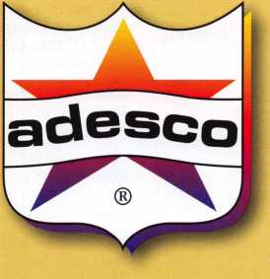

With a newly expanded line of UL@-rated safes, Adesco provides the best available protection against fire, impact, burglary and other disasters. Whether your customer base is primarily retail & commercial, US government, or residential, Adesco has literally hundreds of models and styles to suit their needs and protect their vital records, cash, and assets. Offer the best. Offer Adesco.

**1 “800-694*9340 * [www.adesco.com](http://www.adesco.com) A member of the FireKing® Security Group.**

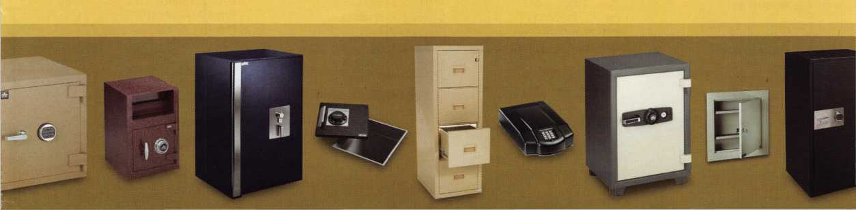

Distributor

**1 st In Hardware, Inc.**

Phone: Phone: 410-646-9900 Fax: 410-646-0045 www. 1 stinhardware.com

**ADEL Fingerprint Technology, LLC**

Phone: 909-595-1222 Fax: 909-595-1667

**Accredited Lock Supply Co.**

Phone: 800-652-2835 Fax: 201-865-2435 [www.acclock.com](http://www.acclock.com)

**Andrews Wholesale Lock Supply**

Phone: 717-272-7422 Fax: 717-274-8659 [www.andrewslock.com](http://www.andrewslock.com)

**Boyle & Chase Inc.**

Phone: 800-325-2530 Fax: 800-205-3500 [www.boyleandchase.com](http://www.boyleandchase.com)

**Clark Security Products**

Phone: 858-974-6740 Fax: 858-974-6720 [www.clarksecurity.com](http://www.clarksecurity.com)

**Cook's Building Specialties**

Phone: 505-883-5701 Fax: 505-883-5704

**Dire's Lock & Key Company**

Phone: 303-294-0176 Fax: 303-294-0198

**Direct Security Supply, Inc.**

Phone: 800-252-5757 Fax: 800-452-8600

**Discount Key Machines.Com/Busch**

Phone: 800-332-8724 Fax: 407-363-4666

**Doyle Security Products**

Phone: 800-333-6953 Fax: 612-521-0166 [www.doylesecurity.com](http://www.doylesecurity.com)

**Dugmore and Duncan, Inc.**

Phone: 888-384-6673 Fax: 888-329-3846

**E. L. Reinhardt Co., Inc.**

Phone: 800-328-1311 Fax: 651-481-0166 [www.elreinhardt.com](http://www.elreinhardt.com)

**Ewert Wholesale Hardware**

Phone: 800-451-0200 Fax: 708-597-0881

**Foley-Belsaw Company**

Phone: 800-821-3452 Fax: 816-483-5010 [www.foley-belsaw.com](http://www.foley-belsaw.com)

**Fried Brothers Inc.**

Phone: 800-523-2924 Fax: 215-592-1255 [www.fbisecurity.com](http://www.fbisecurity.com)

|  |  |  |  |  |
| --- | --- | --- | --- | --- |
| p 1 | a | s s o | c i | Q  CD |
| ¥ |  | mem | b e | r s |
| H.L Flake Co.  Phone: 800-2314105 | | Omaha Wholesale Hardware  Phone: 800-238-4566 | | Manufacturer |

Fax: 713-926-3399 [www.hlflake.com](http://www.hlflake.com)

**Hans Johnsen Company**

Phone: 214-879-1550 Fax: 214-879-1530 [www.hjc.com](http://www.hjc.com)

**Hardware Agencies, Ltd.**

Phone: 416-462-1921 Fax: 416-462-1922 [www.hardwareagencies.com](http://www.hardwareagencies.com)

**IDN Incorporated**

Phone: 817-421-5470 Fax: 817-421-5468 [www.idn-inc.com](http://www.idn-inc.com)

**Instant Hardware Delivery, Inc**

Phone: 800-355-1107 Fax: 800-663-8518

**Intermountain Lock & Supply**

Phone: 800-453-5386 Fax: 801-485-7205

[www.intermountainlock.com](http://www.intermountainlock.com)

**International Electronics, Inc**

Phone: 800-343-9502 Fax: 617-821-4443

**Jo Van Distributors**

Phone: 416-288-6306 Fax: 416-752-8371 [www.jovanlock.com](http://www.jovanlock.com)

**L V Sales Inc**

Phone: 323-661-4746 Fax: 323-661-1314 [www.lvsales.com](http://www.lvsales.com)

**Lockmasters, Inc.**

Phone: 859-885-6041 Fax: 859-885-7093 [www.lockmasters.com](http://www.lockmasters.com)

**Locks Company**

Phone: 800-288-0801 Fax: 305-949-3619

**Locksmith Ledger International**

Phone: 847-454-2700 Fax: 847-454-2759 [www.lledger.com](http://www.lledger.com)

**McDonald Dash Locksmith Supply**

Phone: 800-238-7541 Fax: 901-366-0005 [www.mcdonalddash.com](http://www.mcdonalddash.com)

**Monaco Lock Co.**

Phone: 800-526-6094 Fax: 800-845-5625 [www.monacolock.com](http://www.monacolock.com)

**NLS Lock Supply Dba Nevada Lock S**

Phone: 702-737-0500 Fax: 702-737-7134

Fax: 402-444-1664 [www.omahawh.com](http://www.omahawh.com)

**Phoenix Safe International LLC**

Phone: 765-483-0954 Fax: 765-483-0962 [www.phoenixsafeusa.com](http://www.phoenixsafeusa.com)

**Positive Identity Solutions**

Phone: 704-663-1175 Fax: 704-660-1301 [www.pids-usa.com](http://www.pids-usa.com)

**RA-Lock Company**

Phone: 972-775-6301 Fax: 972-775-6316 [www.ralock.com](http://www.ralock.com)

**Security Distributors Inc**

Phone: 800-333-6953 Fax: 612-524-0166

**Security House**

Phone: 905-669-5300 Fax: 905-660-6313 [www.securityhouselock.com](http://www.securityhouselock.com)

**Security Lock Distributors**

Phone: 800-847-5625

Fax: 800-878-6400

[www.securitylockdistributors.com](http://www.securitylockdistributors.com)

**Southern Lock and Supply Co.**

Phone: 727-541-5536 Fax: 727-544-8278 [www.southernlock.com](http://www.southernlock.com)

**Stone & Berg Wholesale**

Phone: 800-225-7405 Fax: 800-535-5625

**Streetwise Security Products**

Phone: 252-830-5577 Fax: 252-830-5542

**The Locksmith Store Inc.**

Phone: 847-364-51 1 1 Fax: 847-364-5125 [www.locksmithstore.com](http://www.locksmithstore.com)

**Timemaster Inc.**

Phone: 859-259-1878 Fax: 859-255-0298 [www.time-master.com](http://www.time-master.com)

**Top Notch Distributors, Inc.**

Phone: 800-233-4210 Fax: 800-854-4146 [www.topnotch.bz](http://www.topnotch.bz)

**Turn 10 Wholesale**

Phone: 800-848-9790 Fax: 800-391-4553

**U.S. Lock Corp.**

Phone: 800-925-5000 Fax: 800-338-5625 [www.uslock.com](http://www.uslock.com)

**Wilson Safe Company**

Phone: 215-492-7100 Fax: 215-492-7104 [www.wilsonsafe.com](http://www.wilsonsafe.com)

**A & B Safe Corporation**

Phone: 800-253-1267 Fax: 856-863-1208 [www.a-bsafecorp.com](http://www.a-bsafecorp.com)

**ABUS Lock Company**

Phone: 800-352-2287 Fax: 602-516-9934 [www.abus.com](http://www.abus.com)

**Access Security Products Ltd.**

Phone: 905-337-7874 Fax: 905-337-7873 [www.access-safe.com](http://www.access-safe.com)

**Adams Rite Mfg Company**

Phone: 800-872-3267 Fax: 800-232-7329 [www.adamsrite.com](http://www.adamsrite.com)

**Adesco Safe Mfg. Company**

Phone: 800-694-9340 Fax: 562-408-6427 [www.adesco.com](http://www.adesco.com)

**Adrian Steel Company**

Phone: 800-677-2726 Fax: 517-265-5834 [www.adriansteel.com](http://www.adriansteel.com)

**Advanced Diagnostics USA Inc**

Phone: 650-876-2020 Fax: 650-876-2022 [www.autokeys.com](http://www.autokeys.com)

**Alarm Controls Corporation**

Phone: 631-586-4220 Fax: 631-586-6500 [www.alarmcontrols.com](http://www.alarmcontrols.com)

**All Five Tool Company, Inc.**

Phone: 860-583-1691 Fax: 860-583-4516 [www.all5tool.com](http://www.all5tool.com)

**American Security Products**

Phone: 909-685-9680x2013 Fax: 909-685-9685 [www.amsecusa.com](http://www.amsecusa.com)

**BWD Lockcraft**

Phone: 973-728-3707 Fax: 973-728-3731 [www.bwdautomotive.com](http://www.bwdautomotive.com)

**Bianchi USA, Inc.**

Phone: 800-891-2118 Fax: 216-803-0202 [www.bianchil770usa.com](http://www.bianchil770usa.com)

**Buddy Products**

Phone: 312-733-6400 Fax: 312-733-8356 [www.buddyproducts.com](http://www.buddyproducts.com)

**CCL Security Products**

Phone: 800-733-8588 Fax: 847-537-1800 [www.cclsecurity.com](http://www.cclsecurity.com)

Keynotes • September 2006

associate

**members**

**CompX Security Products**

Phone: 864-297-6655 Fax: 864-297-9987 [www.compxnet.com](http://www.compxnet.com)

**D&D Technologies (USA), Inc.**

Phone: 714-677-1300x292 Fax: 714-677-1299 [www.ddtechusa.com](http://www.ddtechusa.com)

**DETEX Corp.**

Phone: 800-729-3839 Fax: 830-620-671 1 [www.detex.com](http://www.detex.com)

**Don-Jo Manufacturing, Inc.**

Phone: 978-422-3377 Fax: 978-422-3467 [www.don-jo.com](http://www.don-jo.com)

**Door Controls International**

Phone: 800-742-3634 Fax: 800-742-0410 [www.doorcontrols.com](http://www.doorcontrols.com)

**Door Jamb Armor/A&G Security**

Phone: 201-490-5381 Fax: 201-490-5389 [www.djarmor.com](http://www.djarmor.com)

**Doorking Inc.**

Phone: 800-826-7493 Fax: 310-641-1586 [www.doorking.com](http://www.doorking.com)

**E-Lock USA**

Phone: 434-589-5913 Fax: 434-589-3738 [www.e-lock-usa.com](http://www.e-lock-usa.com)

**FireKing Security Products**

Phone: 800-457-2424 Fax: 800-896-6606

**Jackson Corporation**

Phone: 323-269-8111 Fax: 800-888-6855 [www.jacksonexit.com](http://www.jacksonexit.com)

**Jet Hardware Mfg., Co.**

Phone: 718-257-9600 Fax: 71 8-257-0973 [www.jetkeys.com](http://www.jetkeys.com)

**KABA ILCO Corp.**

Phone: 252-446-3321 Fax: 252-446-4702 [www.kaba-ilco.com](http://www.kaba-ilco.com)

**KEY-BAK/West Coast Chain Mfg.**

Phone: 909-923-7800 Fax: 909-923-0024 [www.keybak.com](http://www.keybak.com)

**Kenstan Lock Company**

Phone: 516-576-9090x315 Fax: 516-576-0100 [www.kenstan.com](http://www.kenstan.com)

**Keri Systems Inc.**

Phone: 408-451-2520 Fax: 408-441-0309 [www.kerisys.com](http://www.kerisys.com)

**Knaack Manufacturing Co.**

Phone: 800-456-7865 Fax: 815-459-9097 [www.weatherguard.com](http://www.weatherguard.com)

**Kustom Key Inc.**

Phone: 800-537-5397 Fax: 800-235-4728 [www.kustomkey.com](http://www.kustomkey.com)

**LAB Security**

Phone: 800-243-8242 Fax: 860-583-7838

**Major Mfg, Inc.**

Phone: 714-772-5202 Fax: 714-772-2302 [www.majormfg.com](http://www.majormfg.com)

**Maxcess Card Systems Ltd**

Phone: 949-492-5964 Fax: 949-492-0415 [www.maxcess-card.com](http://www.maxcess-card.com)

**Medeco Security Locks**

Phone: 540-380-5000 Fax: 540-380-5010 [www.medeco.com](http://www.medeco.com)

**Mil-Comm Products Co Inc**

Phone: 201-935-8561 Fax: 201-935-6059

**Promet Safe Inc.**

Phone: 860-436-6246 Fax: 860-436-6876 [www.promet-safe.com](http://www.promet-safe.com)

**Protex Safe Co., LLC**

Phone: 818-610-8030 Fax: 818-610-8004 [www.protexsafe.com](http://www.protexsafe.com)

**ROFU International Corp.**

Phone: 253-922-1828 Fax: 253-922-7272 [www.rofu.com](http://www.rofu.com)

**Rutherford Controls Int'l Co.**

Phone: 519-621-7651 Fax: 519-621-7939 [www.rutherfordcontrols.com](http://www.rutherfordcontrols.com)

**STRATTEC Security Corp.**

Phone: 414-247-3333 Fax: 414-247-3564 [www.aftermarket.strattec.com](http://www.aftermarket.strattec.com)

**Security Solutions**

Phone: 405-376-1600 Fax: 405-376-6870 . [www.securitysolutions-usa.com](http://www.securitysolutions-usa.com)

**Select Engineered Systems**

Phone: 305-823-5410 Fax: 305-823-5215 [www.selectses.com](http://www.selectses.com)

**Townsteel, Inc.**

Phone: 626-858-5080 Fax: 626-858-3393 [www.townsteel.com](http://www.townsteel.com)

**UCA Inc**

Phone: 972-437-4696 Fax: 972-692-7056 [www.ibuttonlock.com](http://www.ibuttonlock.com)

**Videx Inc.**

Phone: 541-758-0521 Fax: 541-752-5285 [www.videx.com](http://www.videx.com)

**YSG Door Security Consultants, Inc.**

Phone: 800-438-1951 Fax: 800-338-0965

**WMV Innovation Company**

Phone: 888-474-2341 [www.sure-strike.com](http://www.sure-strike.com)

Service

**Organization**

**Allstate Insurance Company**

Phone: 847-551-2181 Fax: 847-551-2732 [www.allstate.com](http://www.allstate.com)

[www.fkisecuritygroup.com](http://www.fkisecuritygroup.com)

**Framon Manufacturing Company Inc.**

Phone: 989-354-5623 Fax: 989-354-4238 [www.framon.com](http://www.framon.com)

**G-U Hardware Inc.**

Phone: 757-877-9020 Fax: 757-877-9720 [www.g-u.com](http://www.g-u.com)

**HPC, Inc.**

Phone: 847-671-6280 Fax: 847-671-6343

[www.hpcworld.com](http://www.hpcworld.com)

**HY-KO Products Co.**

Phone: 330-467-7446 Fax: 330-467-7442

**Hammerhead Industries, Inc.**

Phone: 805-658-9922 Fax: 805-658-8833 [www.gearkeeper.com](http://www.gearkeeper.com)

**Ingersoll Rand Security Technologies**

Phone: 317-805-5713 Fax: 317-805-5779 [www.schlagelock.com](http://www.schlagelock.com)

[www.labpins.com](http://www.labpins.com)

**La Gard Inc.**

Phone: 310-325-5670 Fax: 310-325-5615 [www.lagard.com](http://www.lagard.com)

**Lock America, Inc. dba L.A.I. Group**

Phone: 714-373-2993 Fax: 714-373-2998 [www.laigroup.com](http://www.laigroup.com)

**LockPicks.Com/Brockhage Tools**

Phone: 408-437-0505 Fax: 408-516-9642

**Lucky Line Products, Inc.**

Phone: 858-549-6699 Fax: 858-549-0949 [www.luckyline.com](http://www.luckyline.com)

**M.A.G. Manufacturing**

Phone: 714-891-5100 Fax: 714-892-6845 [www.magmanufacturing.com](http://www.magmanufacturing.com)

**MUL-T-LOCK USA, Inc.**

Phone: 800-562-3511 Fax: 973-778-4007 [www.mul-t-lockusa.com](http://www.mul-t-lockusa.com)

**Sargent & Greenleaf, Inc.**

Phone: 859-885-9411 Fax: 859-885-3063 [www.sargentandgreenleaf.com](http://www.sargentandgreenleaf.com)

**Sargent Manufacturing Co.**

Phone: 800-727-5477 Fax: 888-863-5054 [www.sargentlock.com](http://www.sargentlock.com)

**Schwab Corp.**

Phone: 765-447-9470 Fax: 765-447-8278 [www.schwabcorp.com](http://www.schwabcorp.com)

**Securifort Inc**

Phone: 819-359-2226 Fax: 819-359-2218 [www.securifort.com](http://www.securifort.com)

**Securitron Magnalock Corp.**

Phone: 775-355-5625 Fax: 775-355-5636 [www.securitron.com](http://www.securitron.com)

**Security Door Controls**

Phone: 805-494-0622 Fax: 805-494-8861 [www.sdcsecurity.com](http://www.sdcsecurity.com)

**Cardservice Mobile Solutions**

Phone: 561-210-8488 Fax: 561-953-6268 [www.cardservicems.com](http://www.cardservicems.com)

**Cross Country Automotive Services**

Phone: 800-541-2262 Fax: 781-393-0256 [www.argosi.com](http://www.argosi.com)

**Massglass & Door Service**

Phone: 888-742-8837 Fax: 805-497-2255 [www.massglass.com](http://www.massglass.com)

**SalesGenie.Com**

Phone: 402-593-4500 [www.salesgenie.com](http://www.salesgenie.com)

**The Mechanic Group, Inc.**

Phone: 845-735-0700 Fax: 845-735-8383 [www.mechanicgroup.com](http://www.mechanicgroup.com)

**Webster Safe & Lock Co., Inc.**

Phone: 901-332-291 1 Fax: 901-332-2878 [www.webstersinc.com](http://www.webstersinc.com)



Keynotes • September 2006



**2006 CONVENTION LEGISLATIVE HIGHLIGHTS**

For those of you who were not able to make the 50th Celebration of ALOA in Las Vegas, you missed some great legislative meetings! Here are the highlights:

* NASTF Vehicle Security Committee Meeting

Locksmiths, distributors and representatives from auto manufacturers sat down at the ALOA Convention to hear updates on the National Automotive Services Task Force (NASTF) Vehicle Security Committee. They reviewed the latest efforts to establish a locksmith registry adminis­tered by ALOA that all locksmiths can join and be eligi­ble for key codes from auto manufacturers who partici­pate in the program. For the minutes of the meeting go to [www.nastf.org](http://www.nastf.org).

The next NASTF meeting will be held in Las Vegas dur­ing Automotive Aftermarket Industry Week. The meeting will start at 1:30 p.m. on November 1, 2006 at The Mirage Hotel & Casino in Room C2 of the event center. This is an open meeting and registration is not required.

* STATE OF THE STATES ROUNDTABLE

More than 40 representatives from ALOA chapters and locksmith associations across the US and Europe met to share concerns, ideas and updates on what is happen ing in their states/countries. ALOA's Legislative Manager Tim McMullen, JD, CAE began the meeting with a leg­islative update about bills introduced in 2006 that affect­ed the security industry. He also gave an update on ALOA's efforts to pass federal legislation that would allow associations to offer a health coverage plan to their members through an insurance provider. Tim dis­cussed the progress of the NASTF Vehicle Security Committee (see above), and informed everyone of the new Take Action! web-based tool where locksmiths can directly contact their federal and state representatives with just the click of a button. Check it out at [www.aloa.org/legislation](http://www.aloa.org/legislation).

Much was discussed about phony locksmiths cropping up all over the US and how this problem is personally

affecting many locksmiths' own businesses. The story is familiar in many states: an out-of-state company hires a number of "locksmiths" in the area to sub-contract its work using assumed business names, fake addresses and phone numbers. Many times consumers have been over-sold, under serviced, or just plain lied to! ALOA member Mike Bronzell has taken the lead to educate locksmiths, the government and the media on this grow­ing problem. He shared the successful efforts in Illinois to prosecute one of these phony locksmiths, and what other states are doing to make sure the industry's image doesn't suffer. To see how the Illinois Attorney General tackled this problem, go to [www.aloa.org](http://www.aloa.org).

For the final 75 minutes, chapter and association leaders took turns describing the many issues facing their states. Alabama, Oklahoma and Tennessee gave insight on their recent success in passing locksmith licensing. California, New Jersey and Texas gave updates regard­ing their licensing laws. Michigan, Minnesota, Vermont and Washington state talked about their efforts (or not) to pass locksmith licensing laws.

But it wasn't just about legislative matters either. The Pacific Locksmith Association talked about its efforts with the California Locksmith Association to offer educational classes to locksmiths in Northern California and Southern Oregon. Maryland asked for ideas about how to strengthen locksmith organizations in their state, and Colorado helped give insight on their successful efforts.

David O'Toole, President of the European Locksmith Federation updated his American colleagues about recent consolidation of the industry throughout Europe and new key cutting technology that is a step away from a vending machine!

By far, this was the largest and most successful Roundtable to date. Make sure to come next year in Charlotte, North Carolina!

Keynotes • September 2006



• Legislative Action Network Council Reception

ALOA celebrated the efforts of its grassroots legislative team at the annual Legislative Action Network Council Reception. The Council is for those members who have contributed $100 or more to the Legislative Fund.

ALOA's Legislative Manager Tim McMullen, JD, CAE thanked everyone for their hard work to make this year so successful for the locksmith industry. Special awards were given to the three states who worked to get lock­smith licensing passed this year. Legislative Action Network Organization of the Year awards were present­ed to: Alabama Locksmith Association (Dallas C. Brooks and James Turner, Jr, CML, CPS accepting), Oklahoma Master Locksmith Association (Charles Hudecek and Clint Parsons accepting), Tennessee Organization of Locksmiths, Middle Tennessee Locksmith Association, and the East Tennessee Locksmiths Association (Chris Cyree, CPL, Tom Gillingham, Jr. CML, CPS, Jim Wiedman,

CML and accepting). The Legislative Action Network Person of the Year award was presented to Jim Wiedman, CPL for his many years of efforts in making the dream of protecting locksmiths through licensing in Tennessee a reality.

**ALOA MEMBER RUNS FOR COUNTY-WIDE OFFICE**

Since He was promoted to the Patrol Division as a patrol officer at the Chippewa County Sheriff's Department in October 2003, ALOA member Ken Briggs always wanted to lead the organization. That is why he is running for Sheriff of Chippewa County, the fourth largest county in the state of Wisconsin with a population over 70,000. The position oversees 75-100 employees in all facets of county law enforcement. This includes not only the patrol division, but the county jail, investigative division, telecommunica­tions, reserve and recreation division. Ken ran for the posi­tion 14 years ago, and did extremely well running as an independent.

Ken's platform is to bring leadership, fairness and honesty to the position, something Ken believes is lacking under the current Sheriff. He prides himself on leading by example and wants to be known as the "Working Sheriff". Ken's

plan is to evaluate the budget and prioritize spending, pro­mote teamwork within the department, implement more community-based programs, improve communications with the public, update current policies and procedures and introduce the newest technology to improve efficiency.

Ken feels that his strength for the position comes from his cross-training in all areas of emergency services not only in law enforcement but security, fire, and medical training as well. On the campaign trail, he proudly lets folks know that he is a locksmith and has the ability to see where security can be improved and unlawful activity can be prevented.

Ken started his career in 1977 with the Chippewa Falls Police Department. From there Ken has served with the Chippewa County Sheriff's Department since 1981. Ken obtained both Fire and Emergency Medical Technician Certifications and has worked for Chippewa Area Ambulance and the Chippewa Fire Protection District.

Ken also owns and operates Chippewa Valley Lock & Key in Chippewa Falls along with his Wife of 24 years, Janell. They have three children, Jeremy 23, Amy 21, Adam 16, and a nephew Tim 21 that they've cared for since Janell's sister's death six years ago. Ken is also Chairman for the Wisconsin Indianhead Chapter of ALOA.

On his website: [www.briggsforsheriff.com](http://www.briggsforsheriff.com), Ken lists many of his education and training (including investigative lock- smithing and FBI hostage negotiating training!), and proud­ly lists his professional affiliation with ALOA.

Keynotes • September 2006



keynotes

r*j j ft / r~~* i— j / p—.4

,jv... J 3 %ggp

**Marketplace**



**SAFE CORPORATION**

/VFI/V ROTARY HOPPER SAFE

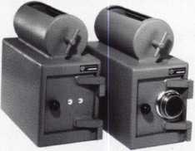

WHEN YOU NEED A SMALLER  
CAPACITY WITH THE SAME  
SECURITY OF OUR LARGER SAFES  
ask for AB-3M

with a dual key or combination lock

A & B SAFE CORPORATION 800-253-1267 114 S. Delsea Drive, Suite 3 856-863-1186

Glassboro, NJ 08066 Fax 856-863-1208

IN-STOCK...MORE SAFES

***FREE Freight Program***

*(30 States)*

**AMSEC** FireKing

Gardall **hayman**

MEIUNK y/CTO/Z

**TURfl** to

**WHOLESALE SERVICE**

800-848-9790

**LOCKSMITH REKEYS  
30 CYLINDERS* IN**

**59 SECONDS!**

**AT MAXCESS ALOA BOOTH.**

Watch him do it at:

**[www.maxcess-card.com](http://www.maxcess-card.com)**

* The new amazing mechanical XTRONIC® card  
operated Cylinders by Maxcess fit most types of locks  
and can be rekeyed by simply inserting a Remaster  
Card. Not a single user card needs replacement.

*locksmith* mDm90Mcmm ^NS^100

Derrick Warner of De's Key Service in Ogden

Utah receives his prize from "Miss Xtronic 2006"

Jennifer Lynn for fastest rekeying.



MAXCESS CARD SYSTEMS

[maxcess@maxcess-card.com](mailto:maxcess@maxcess-card.com)

800-713-4823



Keynotes • September 2006

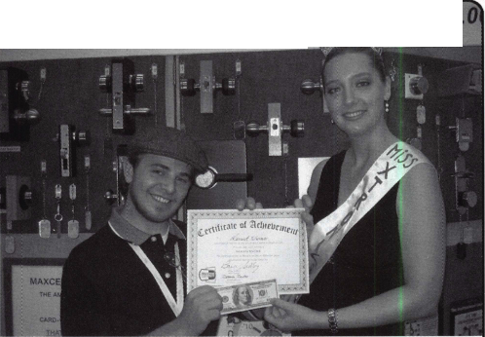

(IJU

T.M.

HIGH PERFORMANCE POWERED HAND TRUCKS

***OPERATOR SAFETY***

Injuries can be virtually eliminated. Ultra Lift does the lift-  
ing so that operator effort required to complete a move is  
minimized. Heavy loads are broken back with ease. The  
operator stays in control by using a combination of motor  
power, balance and leverage in every phase of a move.

***REDUCE LABOR COSTS***

Fewer people are required for any move with Ultra Lift.  
Manpower can be scheduled more productively. Labor  
savings often pay for the Ultra Lift in one month.

***ELIMINATE DAMAGE***

Loads are broken back, set down and moved under power  
with maximum leverage and operator control. Gentle  
handling eliminates bumps, bounces and damage to the  
load and premises.

***INCREASE PROFITS***

Increased operator safety, reduced labor cost and elimina-  
tion of damage to the load and premises all contribute to  
significant increases in profits.

**FOR LITERATURE, VIDEO OR ON-SITE  
DEMONSTRATION, WRITE OR CALL:**

ULTRA LIFT CORPORATION

475 STOCKTON AVENUE, UNIT E SAN JOSE, CA 95126 800-346-3057 408-287-9400 FAX 408-297-1199 E-mail: [info@uItralift.com](mailto:info@uItralift.com) [www.uitralift.com](http://www.uitralift.com)

ULTRA LIFT supplies the power - so you don't have  
to. One person can safely and easily handle loads  
that usually require 2 or 3 people, even up or down  
stairs. TWo people can handle most safes to 1500  
pounds. If safety is your concern, ULTRA LIFT is the  
best move you'll ever make!

**U.S. PATENT 4.570.953**

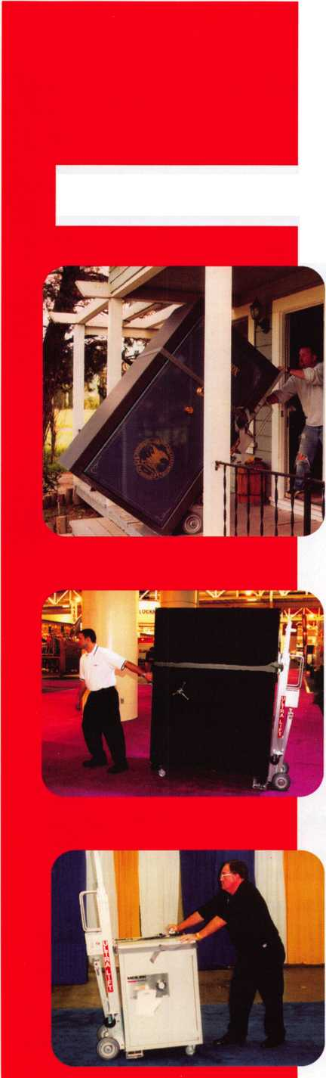

**Stop giving your profit to carpenters and lumberyards!**

|  |  |  |
| --- | --- | --- |
|  | - ! i|)'i 1 f.ti j | o |
| Save time, make |  | If you don’t keep one on |
| more money and |  | your truck, you can’t |
| sell better locks | answer the call |
|  | Because You Can’t Afford False Security ® | |

Standard

Set

Universal

Set

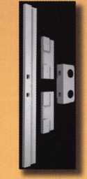

Fits doors with  
standard lock  
spacing

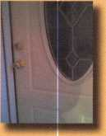

Four-piece steel

isting entry

Fix broken doorjambs and secure your hinges  
without removing the door

Gan be installed in under an hour and painted  
to match the door

Door Shield Hinge Shield

Reinforcing one point on a  
door means that others will  
break when the door is kicked.

Door Iamb Armor reinforces  
several key weak points...

...This is a fix, not a patch

non-standard lock spacing

Home security that actually works...Before intruders enter!™

**wwyif.djarmor.com 1-888-582-2294**

© 2005-2006 A&G Security LlC. All rights reserved. Dow Jamb Armor and Because You Cant Afford False Security are trademarks of A&G Security LLC.

We

Recommend **» «"uiTi.ocK**

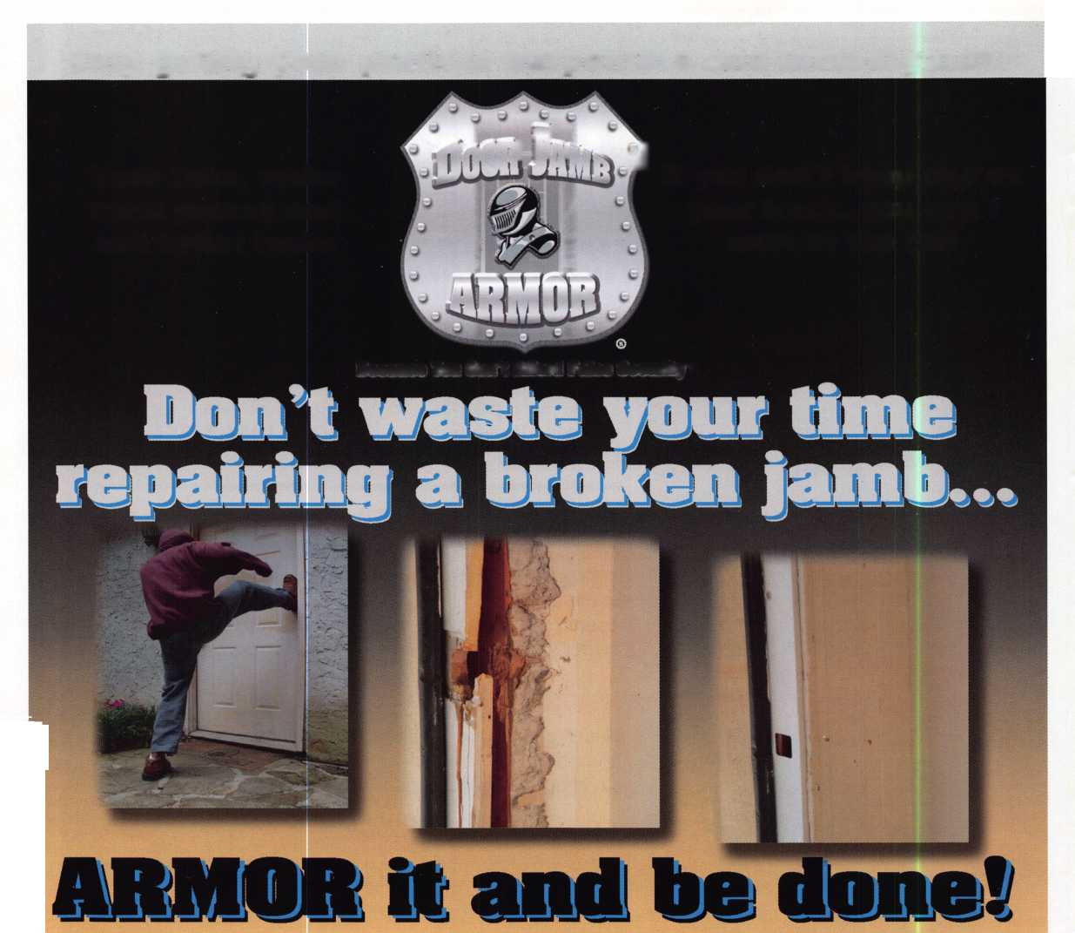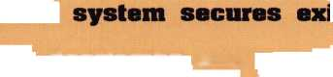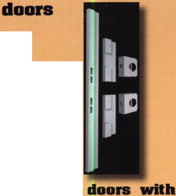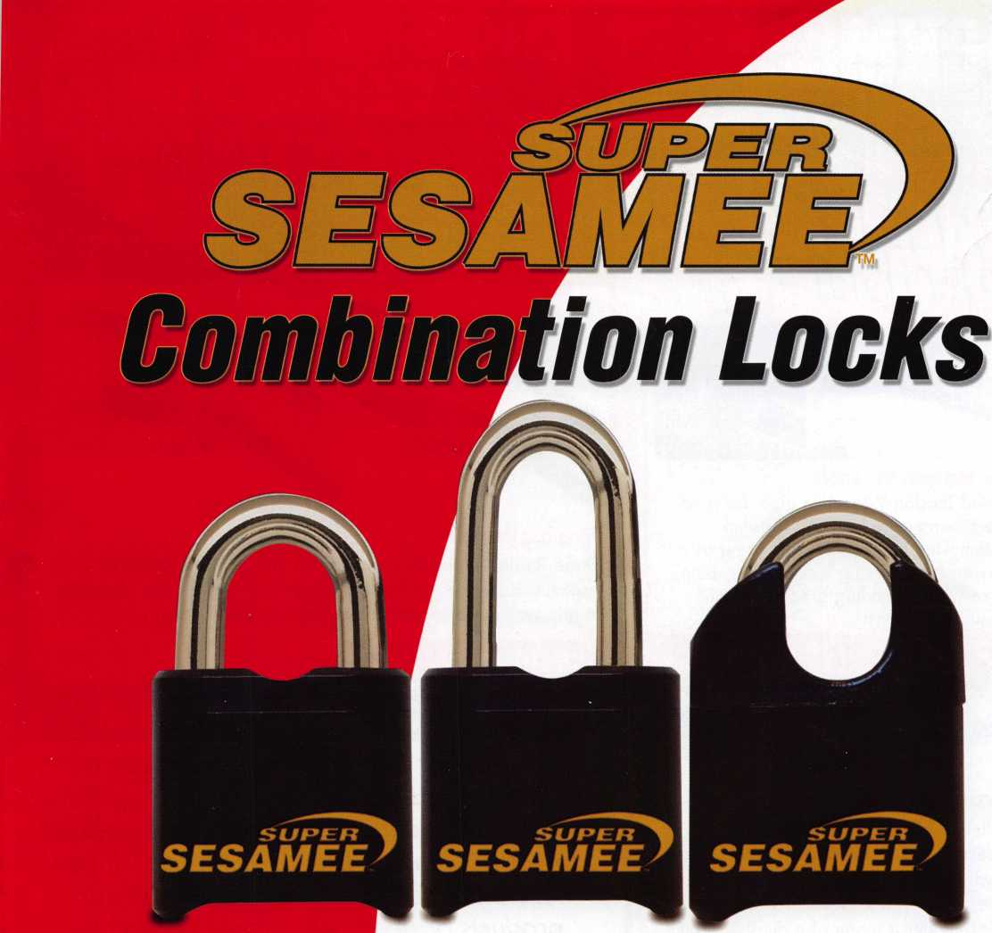

**Security Products**

**A Division of The Eastern Company**

**301 West Hintz Road Wheeling, IL 60090 Telephone: 800.733.8588 Fax: 847.537.1881 [www.cclsecurity.com](http://www.cclsecurity.com)**

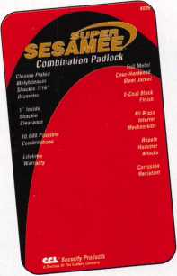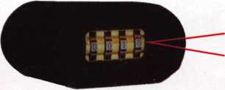

Features & Benefits

* Industrial Strength Combination Lock!
* Resists Hammer and Re-bar Attacks!
* Hardened Steel Full Metal Jacket!
* Hardened Steel Full Metal Jacket Shroud!
* Weather Resistant Black Electrocoating!
* 7/16” Chrome Plated Molybdenum Shackle!
* Inside Shackle Clearances: 1 ” and 2”!
* Shackle Pull Strength: 2,750 pounds!
* All Brass Inner Mechanism!
* Four All Brass Dials!
* 10,000 Changeable Combinations!
* Quick Delivery: Shipped from Stock!

**TIBS**

**Lighted Tension Wrench**

This Lighted Tension Wrench is great for read­ing wafers, examining keyways for stuck wafers, removing broken keys and using as a tension wrench for picking locks. Leaves both hands free while providing great light right where you need it most

**now ofTERinc**

**[ TREE FREIGHT L PROGRAM!**

**Enter to Win! IGas Card Give**

*See below for details

LKM802

LKM801

LKM803

LKM804

**Tension Wrenches**

These Tension wrenches are available in 4 different widths to accommodate any size keyway. Made from high quality materials to grip well in the keyway for maximum control while picking.

*?**■'«

***We Support What We Sale!***

**VW Lock Decoder**

The Audi/VW High Security Lock Decoder makes decoding a two track Audi/VW Locks a cinch and within a minute it accurately reads both type 1 and type 2 locks.

The Slide-Decoder is made of a durable strong stainless steel with no spring wire and with very little practice a locksmith can easily read the correct key code.

Our Customer Service and Soles Deportment

con provide answers to your technical questions

and troubleshoot any technical issues related

to your purchases from LockmastersIf you

ho

lave any technical enquiries about our

products or need help, please contact us.

r' V tf

**LKMVW**

**$425.00**

■NMMIMlMMffli

UjJIJj

J 4JJ-j* ?

**LKM250**

This Wafer Depressor is a must have tool for reading wafer locks. This tool with its offset handle allows you to depress the wafers individually while leaving room to view the keyway with an inspection light or scope.

flflD

EATER !o

**jjUILJU £**

**LKM250**

**$5.00**

To qualify for Free Freight Program, orders must be placed for $150.00 or more, ship ground UPS or mail with-in the continental U.S. 48 states. Total order cannot exceed 501bs. This offer does not include orders with key machines. This promo­tion good 08.01.2006 thru 12.21.2006. Please ask customer service for details.

MEDIA CODE: KEY09

**800.654.0637 •** Fax **859.885.7093 • lockmasters.com •** salesinfo@lockmasters.

**LKM806 $**

^I

**LKM801-804**

**$28.00 each**

